Table of Contents
Introduction 2
User perspective (i.e. the child’s view) 3
The different sections 3
Interactive tour 3
Visit your Barnahus 3
Dashboard user guide 4
Master Admin Onboarding 4
Accessing Your Barnahus Dashboard 5
Inviting Admins 5
Inviting practitioners 5
Setting Up App Content 6
Creating templates 8
Creating a Custom ID 8
Creating a Custom Journey Experience 9
Admin Onboarding 9
Accessing Your Admin Dashboard 10
Inviting Practitioners 10
Creating templates 10
Setting Up App Content 10
Create Custom ID 11
Creating Custom Journey Experiences 12
Practitioner Onboarding 12
Accessing Your Practitioner Dashboard 12
Create a Custom ID 12
Create Custom Journey Experiences 13
Support and Assistance 13

Introduction
Welcome to the Barnahus App! This document will guide you through the onboarding process of the app. The app has been developed to facilitate the child’s journey through Barnahus and ensure that the child receives appropriate information throughout their Barnahus Journey.
In this guide, we will alternate between the perspective of the users and that of practitioners. The users will be the children visiting the Barnahus and the practitioners will be the people working at Barnahus. The perspective of the user is what you can see once you’ve downloaded the app from App Store or Google Store. The practitioners have access to more aspects of the app for setting up the app’s content through the Dashboard.
There are two different sections of the app, one interactive 3D section, and one section where you can visit your local Barnahus. This document will guide you through these two sections and clearly outline the intended purposes of each section.
This document will also highlight the different roles we have created for practitioners in the Dashboard. Not all practitioners using the app will have the same responsibilities and tasks. We have created the following three roles:
1. Master Admin,
2. Admin, and
3. Practitioner.
This document will carefully guide you through the different roles and delineate the differences.
We have structured this document in the following way. We will first show you how the app looks from the perspective of the user and then show you how practitioners can populate the app with pictures and text. We have structured the document in this way for educational purposes: We believe it is easier to understand the responsibilities and tasks of the different practitioners once you have seen what the app looks like from the perspective of the user. Terms like “Admin Dashboard” and “Customised Barnahus Journeys” are easier to understand once you’ve seen what they correspond to for the user.

User perspective (i.e. the child’s view)

The different sections
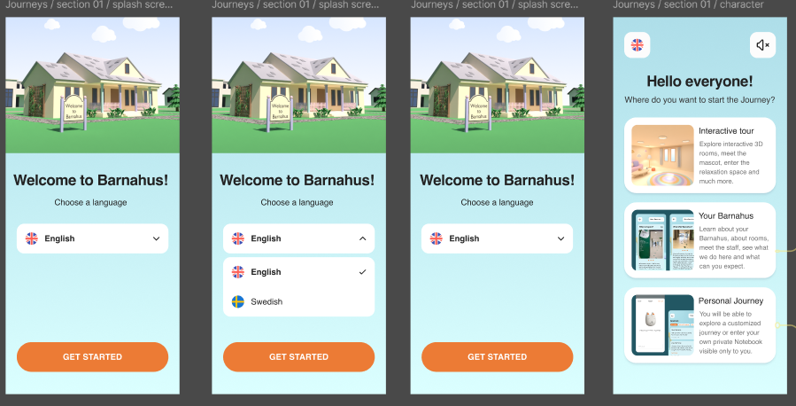
When entering the app as a user, you will have two options:
- A generic 3D interactive tour
- Visit your Barnahus
See the video walkthrough of this section in the app here: [YouTube link]

3D Interactive tour
The 3D Interactive tour is open to the public and is the same for everyone using the app. You as a Barnahus professional cannot make any changes to this section.
The purpose of this section is to give children an overview of what a Barnahus is, what happens there and a brief introduction to the different rooms that may exist in a Barnahus. The Interactive tour provides a very general representation of Barnahus and its rooms.
There are two different 3D interactive tours of Barnahus, one for the age group 3-9 and the other for the age group 10-17. The only difference between the age groups is the design audience in terms of colours and shapes – the contents in the rooms are more or less the same.
In this section you can also find a meditation space, which provides the user with a simple breathing exercise.
See the video walkthrough of this section in the app here: [YouTube link]

Visit your Barnahus
“Visit your Barnahus” is a section that is created by staff from every Barnahus. This section shows the child their unique journey through your Barnahus and what is shown to the child in this section is entirely up to the Barnahus professionals.
The purpose of this section is to give a child a personal introduction to the Barnahus they will/are visiting, what rooms look like and learn about some of the staff that they will meet – with the aim of making the visit seem less scary.
Every Barnahus is responsible for providing content about their Barnahus in this section – this is done through the dashboard which we will go through further down in this document. It is important to note that there are no mandatory fields in this section – it is entirely up to the Barnahus professionals themselves to decide what they would like to include.
This section is restricted and protected by a username and password – only children who have been granted access can view the information about your Barnahus.
The child logs in to this section with a Barnahus ID, functioning as a username, and a Custom ID which functions as a one-time password. The Barnahus ID is automatically generated once a Barnahus has been invited to the dashboard, whereas the Custom ID is a code that the professional generates when they want to create a personal journey for a child (we will go through this in more detail in the user guide below).
In this section the child also has the opportunity to leave comments. The comments are only visible to them, but the Barnahus can disable this feature if they deem it inappropriate.
See the video walkthrough of this section in the app here: [YouTube link]
Please note: We have used example texts and pictures for the video walkthrough of this section. These are just placeholders, and we do not expect you to use them. You will be able to use the pictures and the text you think are appropriate. We highly recommend you give careful thought to what information the children would need and what picture you would like to share.

Dashboard user guide
Not all practitioners using the app will have the same responsibilities and tasks. We have created the following three roles:
Master admin | Add Admins, practitioners, and content to the app, create custom journeys for children
Admin | Add Practitioners and content to the app, create custom journeys for children
Practitioner | Create custom journeys for children
Role Main tasks

This is due to privacy concerns, and some people might benefit from having access to the app, but not access to adjusting the content of the app. Another reason for dividing up the practitioner role into different roles is to divide up the labour efficiently between the different roles.

Master Admin Onboarding
You, as the Master Admin, are the first person to be invited to the dashboard. This person is the main point of contact for that Barnahus.
Your role is to invite other contributors to the dashboard (Admins and Practitioners) and manage the content for the app – i.e. adding information and pictures about your Barnahus, the different rooms and staff. You also have the ability to create custom IDs and custom journeys for the children visiting your Barnahus.
You can manage all sections alone, but you can also invite other people to assist you in setting up the app. Adding an Admin grants them almost identical rights to yours, enabling them to assist with setting up content, adding practitioners and creating custom journeys for children. Adding a practitioner grants them limited rights to create custom journeys for children.

Accessing Your Barnahus Dashboard
1. Accept the invitation email and log in to your Barnahus dashboard
2. Familiarize yourself with the dashboard interface and available functionalities

Inviting Admins
Adding an Admin grants them almost identical rights to yours, enabling them to assist you with setting up the content for the app, adding practitioners and creating custom journeys for children.
See the video tutorial here: https://www.youtube.com/watch?v=REcC54kN7EA
1. Navigate to the “Admins” section  2. Click “Add Admin” | 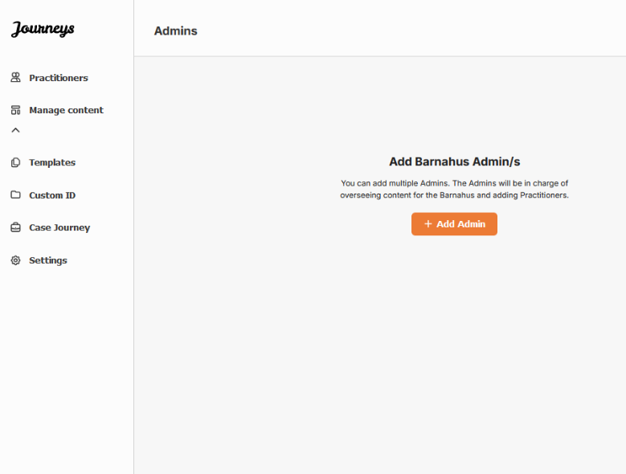
3. Fill in the required details (email, first name, last name) for each Admin – adding a phone number is optional.  The Barnahus location is pre-determined and cannot be changed as you can only add admins to the Barnahus that you are assigned to. | 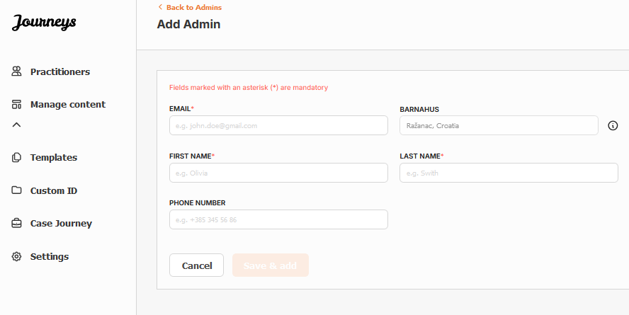
4. Click “Save & Add” to send the invitation email to the Admin.

Inviting practitioners
Adding a practitioner grants them limited rights to create custom journeys for children, they are not able to add any new content but can use the content that has been set up by the Master Admin and the Admins.
See the video tutorial here: https://www.youtube.com/watch?v=2tpkfn8E6oM
1. Navigate to the ‘Practitioners’ tab in the side menu.  2. Click “Add Practitioner” | 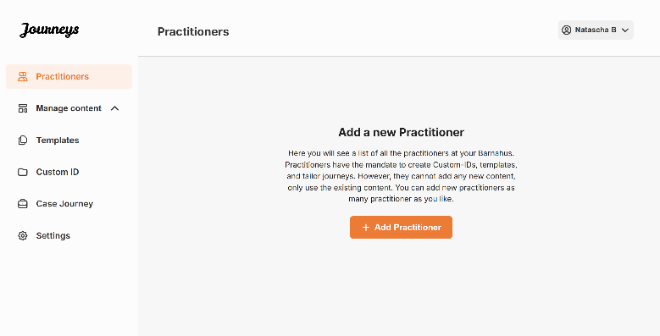

3. Fill in the required details (email, first name, last name, role) for each Practitioner – adding a phone number is optional.  The Barnahus location is pre-determined and cannot be changed as you can only add practitioners to the Barnahus that you are assigned to. | 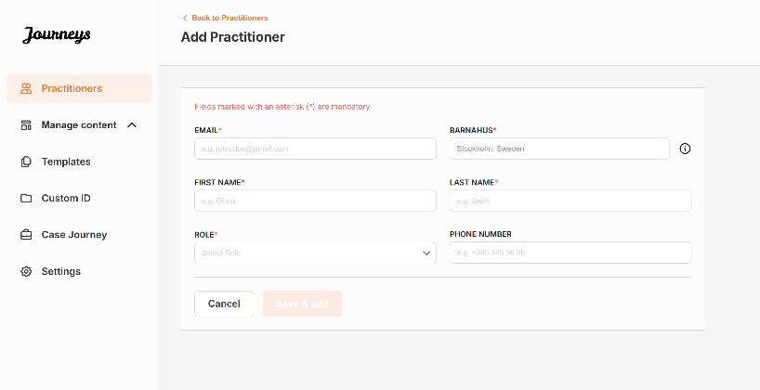
4. Click “Save & add” to send the invitation email to the Practitioner.

Setting Up App Content
Populating the content of the app is one of your main responsibilities, including adding information and pictures about your Barnahus, the different rooms and staff tailored for different levels of maturity.
When you have added the content, you can preview how it will look it the app publishing it. You only need to upload the content in the desired language once, as the content added here will be the same for every child, i.e. general information that does not need to be changed for every child. If you wish to do so, you can add multiple versions of the same content (e.g. languages or age relative – easier or more elaborate text).
See the video tutorial here: [Insert YouTube URL]
Add languages
To set up the content about your Barnahus, you first need to add the languages that you would like to add content in. You do this in the ‘Languages’ tab under ‘Manage content’.  After clicking ‘Add language’, you need to search for the language that you would like to add and enable/disable auto-translation for the selected language. | 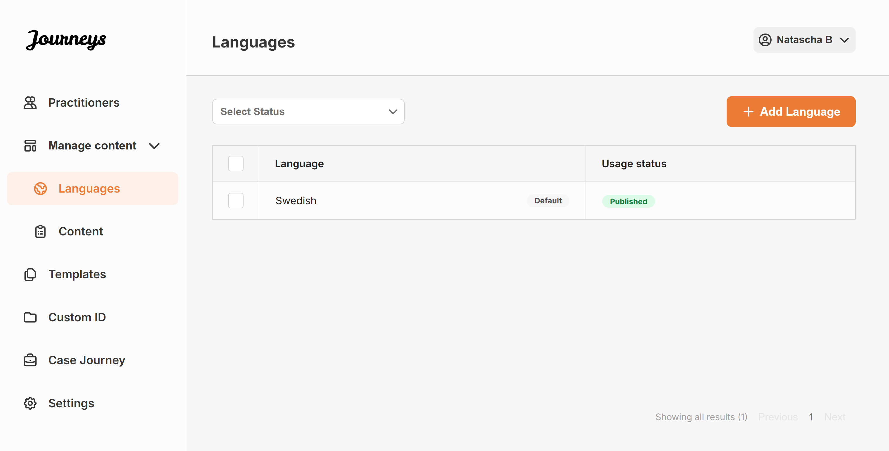
Auto-translate disabled: Having the auto-translate disabled adds the language to the system as a default language – this language will serve as the basis for every other translation.  Auto-translate enabled: Having the auto-translate enabled means that the content that you add in the default language, can be auto-translated to this other language through Google Translate. | 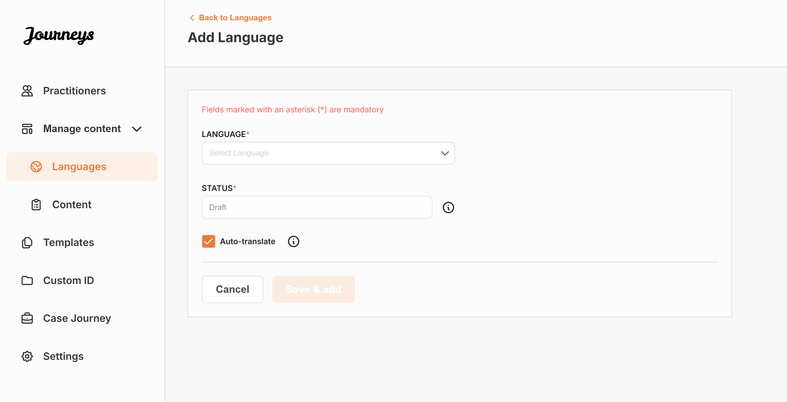
You can add as many languages as you’d like – you do not need to add all languages at once, you can always come back and add more later. We recommend that you start by just adding the default language.
The usage status in the overview showcases whether or not you have published any content in the different languages. Draft indicates that you have not yet published content in that specific language, whereas Published indicates that content has been published in that language.
Add content in default language
1. After you have added one your default language, navigate to the ‘Content’ tab under ‘Manage content’ and select the language that you have chosen as your default language.
2. You can add content in any order you’d like, but for the purpose of this user guide we will walk you through adding content in the order that is being shown in the dashboard: About your Barnahus, Rooms, and Staff.
- About Barnahus: Under ‘About Barnahus’ you will be asked to fill out information about your Barnahus that would be helpful for the child. Keep in mind that this will be the same for all the children, so keep it generic but helpful.  You can add multiple versions of ‘About your Barnahus’ in case you want to have different versions of the text tailored to different age groups. You can also add additional sections about what the child can expect during a visit, and what usually happens/can happen after the visit.  To add more versions of your text or additional sections, click on “+ Add About” – and a new section will appear under the first one (containing title, description, audio transcript, and photo as well) |  | 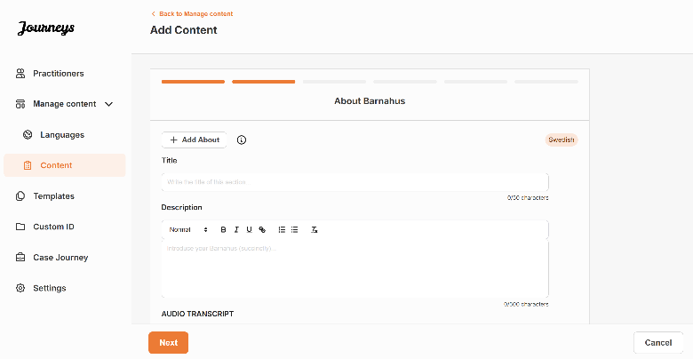
 |  | 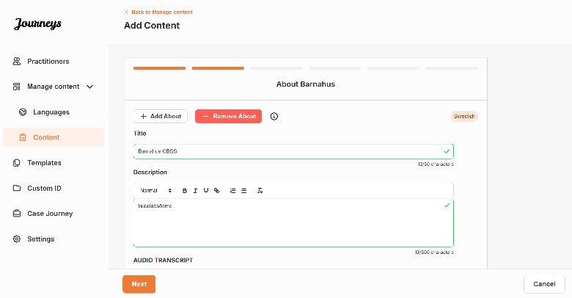
Examples of what you can write:
“About your Barnahus”  Barnahus is a safe and child-friendly place where children who are presumed victims of violence receive the support they need. At Barnahus, law enforcement, social services, physical health and mental health staff work together under one roof. By bringing the professions together and integrating how they work, children don't have to repeat their stories many times. | “What the child can expect”  At Barnahus, you will meet professionals from law enforcement, social services, physical health and mental health, that will provide you support throughout the day. |  | “What happens after the visit”  After your visit to Barnahus, you’ll receive ongoing support focused on helping you feel your best.

- Rooms: Under ‘Rooms’ you will be asked to fill out information about the different rooms in your Barnahus and what usually happens in these different rooms, as well as add photos of the rooms if you’d like. Keep in mind that this will be the same for all the children, so keep it generic but helpful. |  | 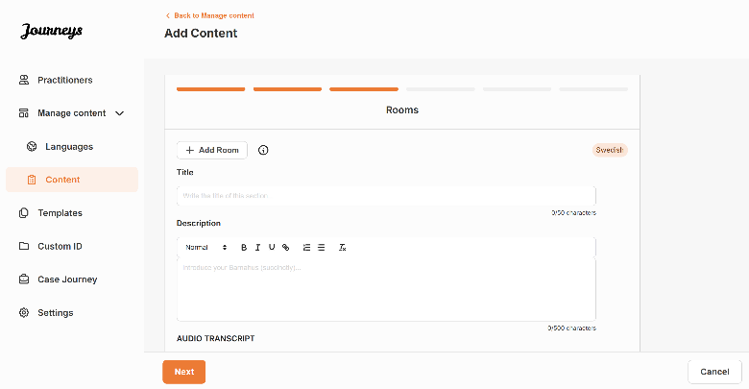
To add more rooms or if you want to have different versions of the text tailored to different age groups, simply click on “+ Add Room” and a new section will appear under the first one (containing title, description, audio transcript, and photo as well) |  | 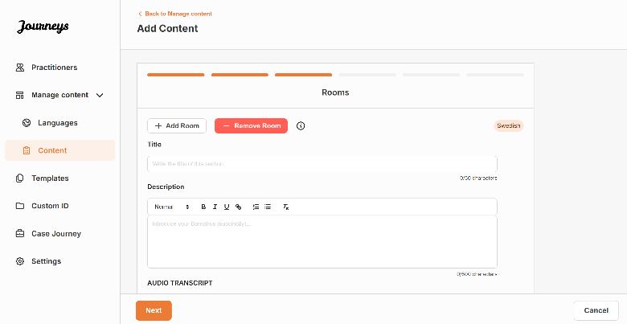
Examples of what you can write:
“Waiting room”  You wait in this soothing environment until an adult comes to take you to the next step in your appointment. There will be toys to play with and books to read. You can ask the people who work there any questions you have about your visit. | “Interview room”  In the interview room, you will talk with a professional who has a lot of experience in talking and listening to young people who may have been mistreated. They will give you instructions and ask questions. You can ask questions if you want, too. Your conversation will be recorded using cameras and microphones. This is so you don't have to be interviewed many times, and to ensure that everything is done correctly. |  | “Examination room”  Here, you can meet a medical professional who will ensure that your health is OK and that you are feeling well. They will tell you what they would like to check, and you will say if it is OK or not. The room looks a lot like a doctor's office, with tools and an examination table.

- Staff: Under ‘Staff’ you will be asked to fill out information about the staff at the Barnahus.
You can add as many ‘Staff’ as you want. To add more staff simply click on “+ Add Staff” and a new section will appear under the first one (with the option to add photo, staff name, staff role and a description). Keep in mind that you will need consent from the staff in question to add a photo of them and how they would like to show their name.
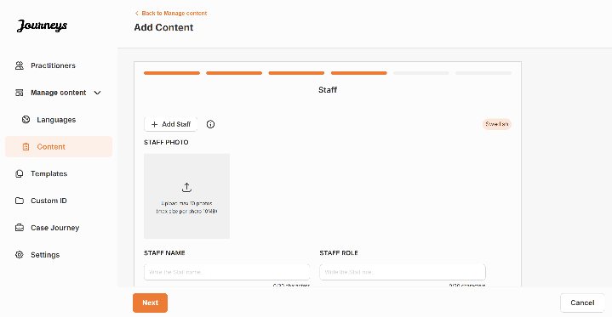 | 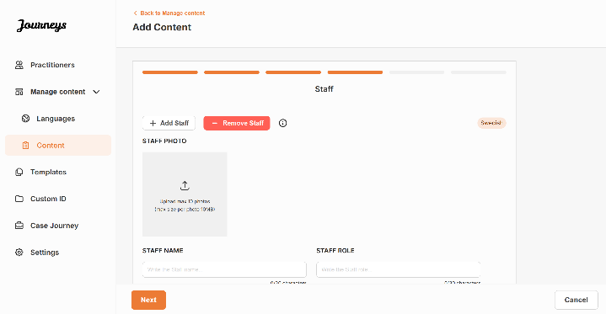
What you can write:
In the description for the staff, you can add anything that could be interesting for a child to know; this can be favourite foods, hobbies, talents and so on. Anything that would humanise the staff for a child that may be scared about meeting new adults.
3. Preview the content before publishing it to see how it will look in the mobile app, and if you’re satisfied – click on publish.
4. Once you have published content in the default language, you can create auto-translated content in another language based on the information that you have just provided (more about this under “Add content in an auto-translated language” below).
5. You can always add additional sections later, for example if you hire new staff and want to add them to the content. To do this, choose the heading that you would like to add a new section to (About, Room or Staff), and click on +Add About/Room/Staff in the top right corner.
6. To edit already added content simply select the section you want to edit by marking the box – and then click “Edit” in the top right corner.
Note: As there is no easy way to distinguish between the content if you have added different versions of the same text by adding additional sections (e.g. text tailored to different age groups) – we recommend that you have a system in place to aid you in distinguishing between the different versions. This could be that you always add the content in a certain order (for example content for the younger age group is always added first and older age group second, or if you include something distinguishing in the text itself (for example using smileys for one age group but not the other, bolding something in the first version but not the second)
Add content in an auto-translated language
1. Once you have added content in the default language you can go back to the languages tab and add other languages with auto-translation enabled. We recommend that you add all the languages that you expect to use for auto-translation at this stage. The auto-translation is generated by Google and needs to be manually checked for mistakes before publishing.
2. Navigate to the ‘Content’ tab under ‘Manage content’ and in the drop-down menu, select the language that you would like to add auto-translated content in.
3. When you click ‘Review & add Content’ you will be shown the auto-translated version of the content that you added in the default language.  Go through the translation and make changes where necessary. | 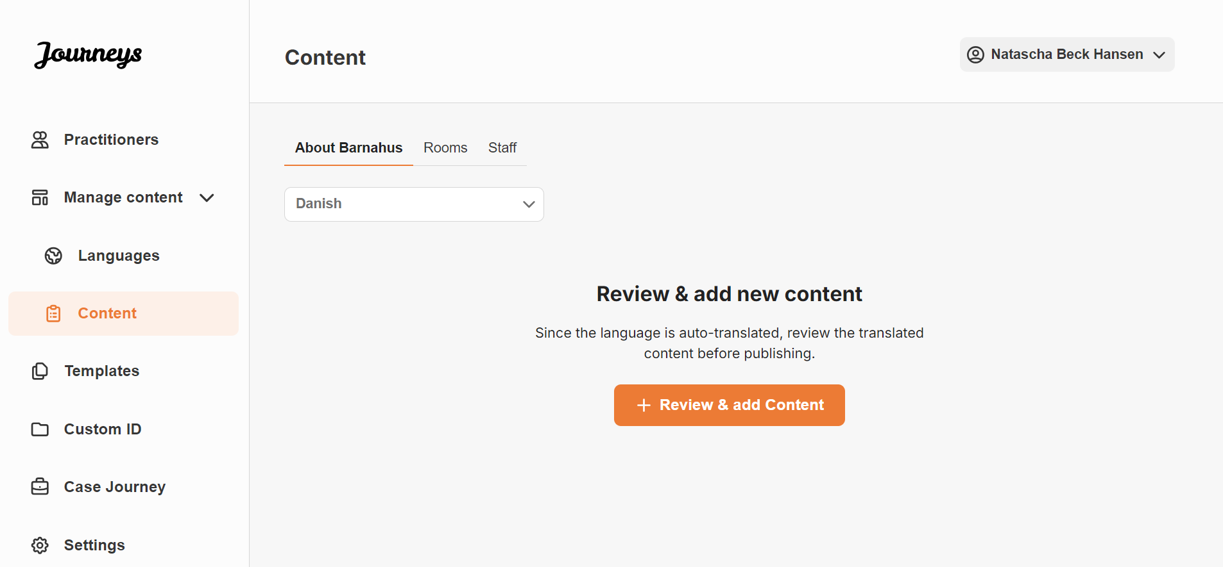
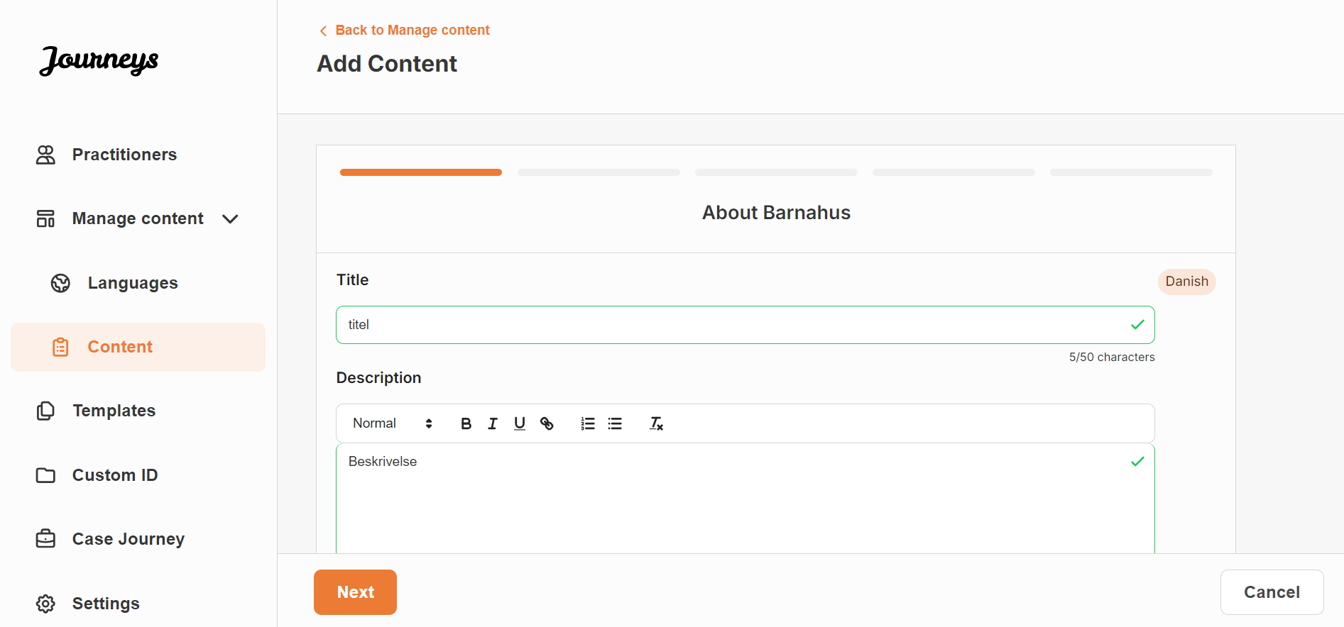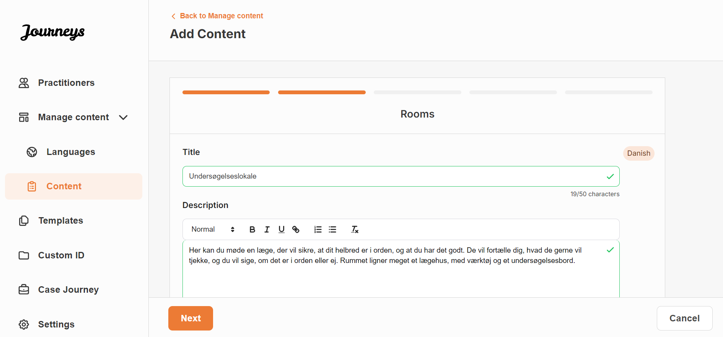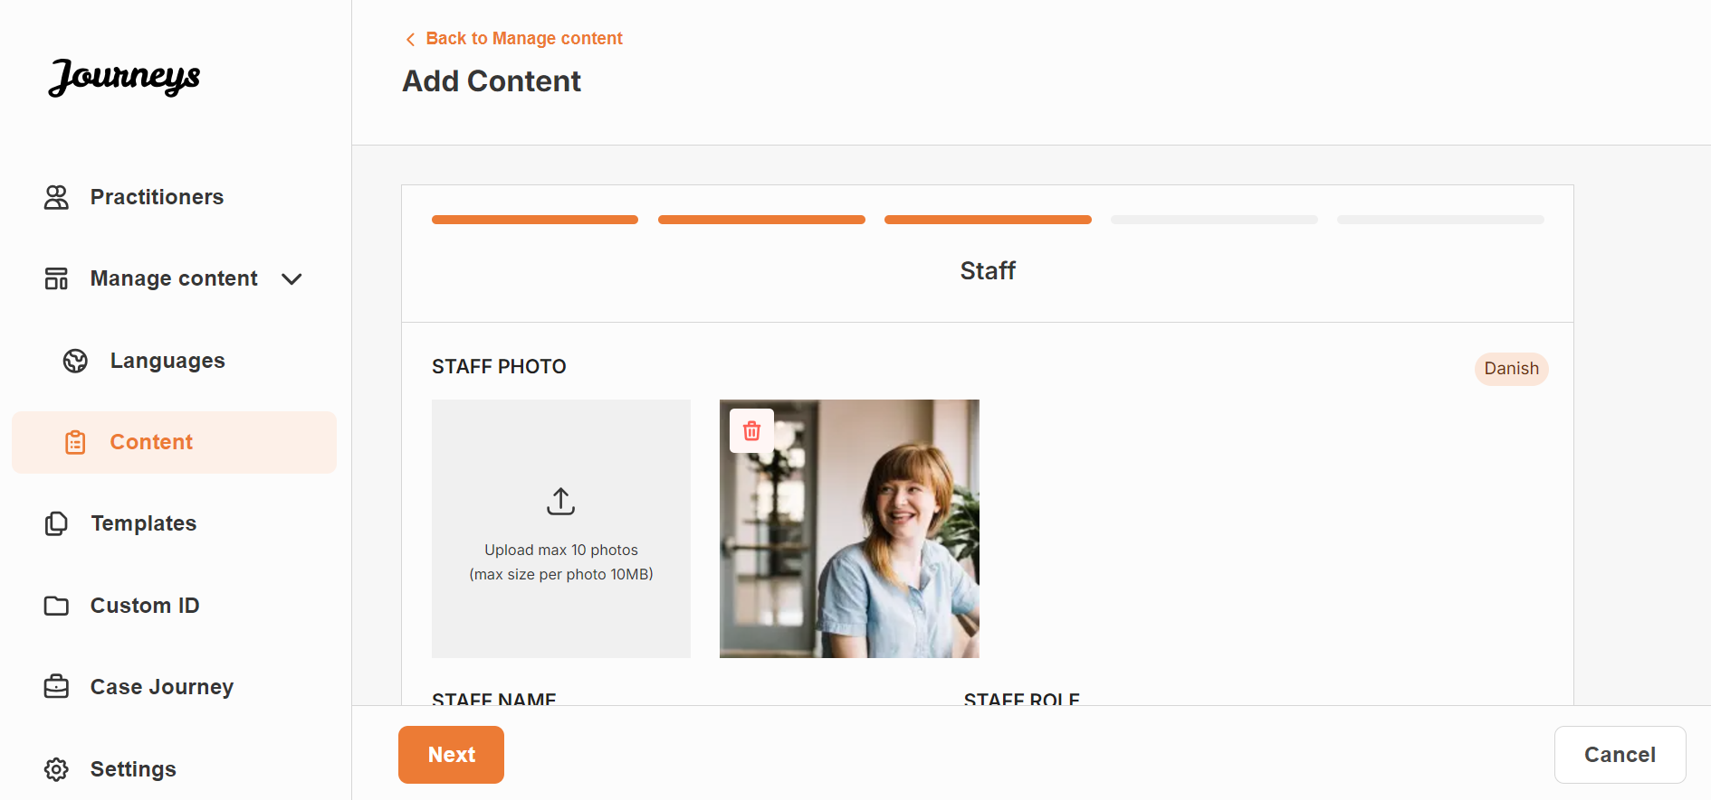
4. Preview how the content will look in the app and publish.
5. Once you have published the translated content, you can choose to review another auto-translated language.  Anytime you update the content in the default language, the auto-translated content will change accordingly. | 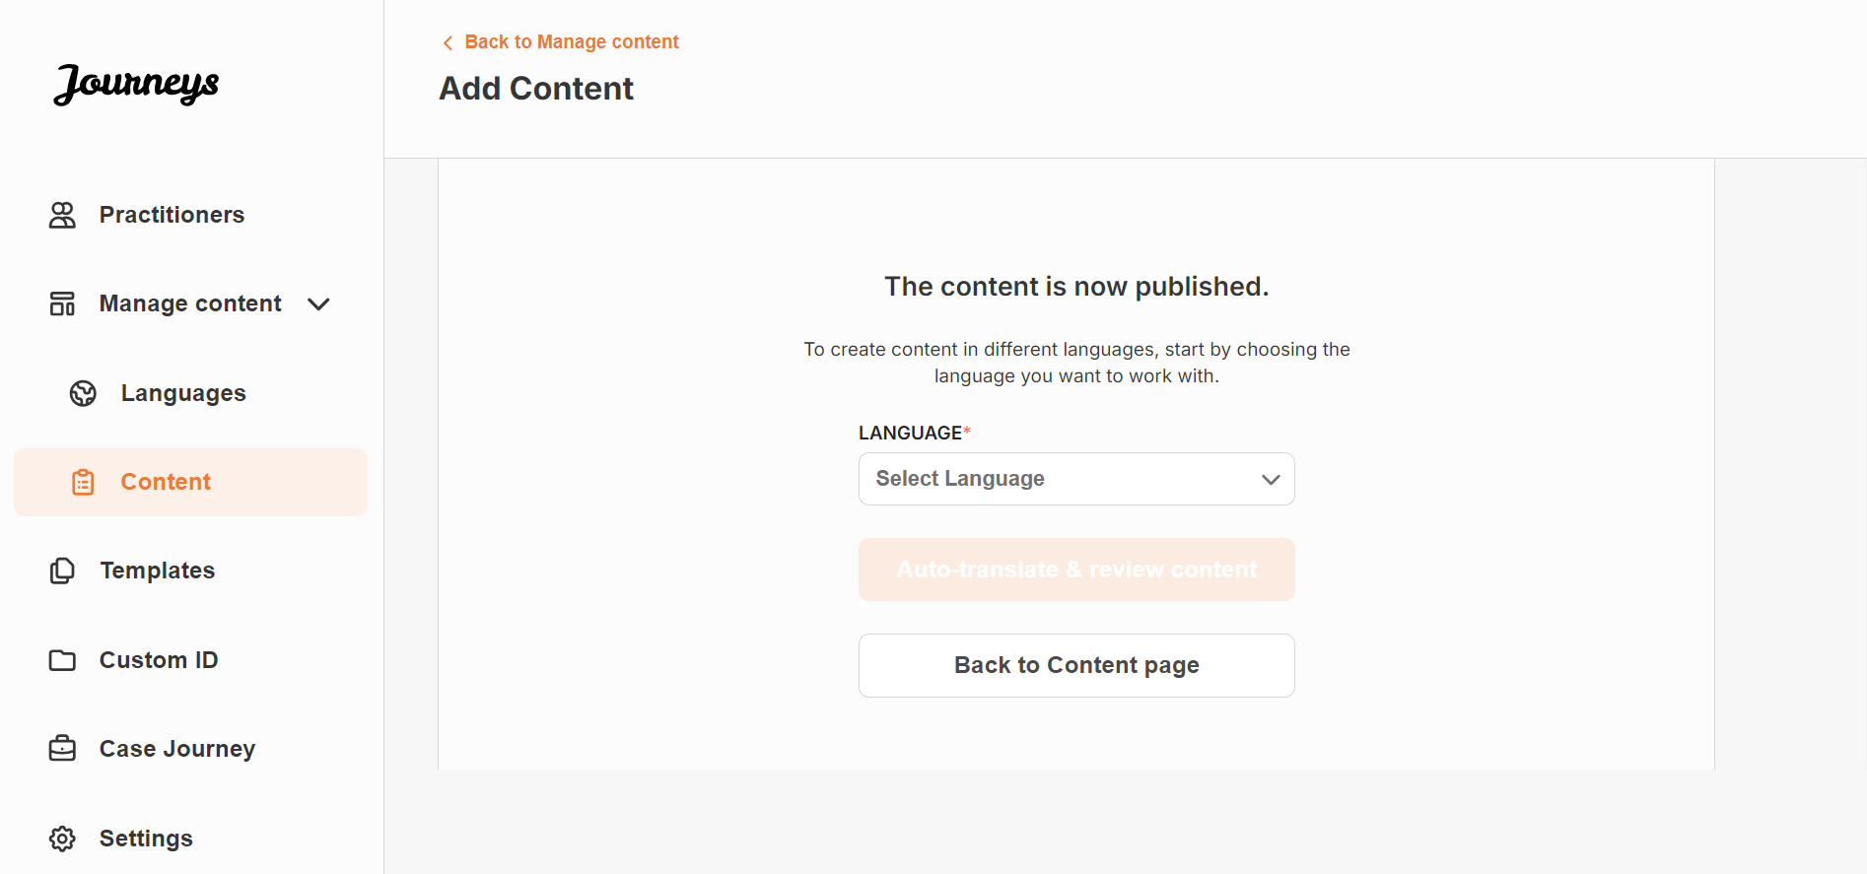

Creating templates
To streamline the process of designing a custom journey for a child, you can create templates using the content you have added. Templates serve as a starting point, simplifying the creation of custom journeys – you can use the created templates as many times as you’d like.
After a template is created, it can be used to build a custom journey for the child and make further adjustments as needed. This flexible approach ensures that the journey meets the unique need of the child, while also saving time during the planning process.
Example:
If you’ve added additional versions of your text tailored to different age groups — e.g. 3–9 years and 10–17 years — you can create separate templates for each group. For instance, you might create a template containing all the text designed for the younger age group.
Additionally, if there are typical cases in your Barnahus where only certain rooms are visited, you can create a template that only includes those rooms, rather than all available rooms.
Another example of how you can use templates is if you’d like to provide the same informative journey to multiple children showing all the rooms and staff in your Barnahus. In this instance, you can create a so called generic template – or two if you have provided text for different age groups. We will go through how to create a journey that can be shared with multiple children under the heading “Create a Custom Journey” on page [insert page].
See the video tutorial here: [Insert YouTube URL]
1. Navigate to the “Templates” tab in the side menu
2. Click on “Add template” – Please note that you cannot create a template before you have added content about your Barnahus
3. Select the language that you would like to create a template for
4. Name your template.  We recommend naming it something that is easily identifiable for other practitioners in your Barnahus as well (e.g. “3-9 Y/O Barnahus Journey”, “10-17 Y/O Journey without Examination room” etc.) | 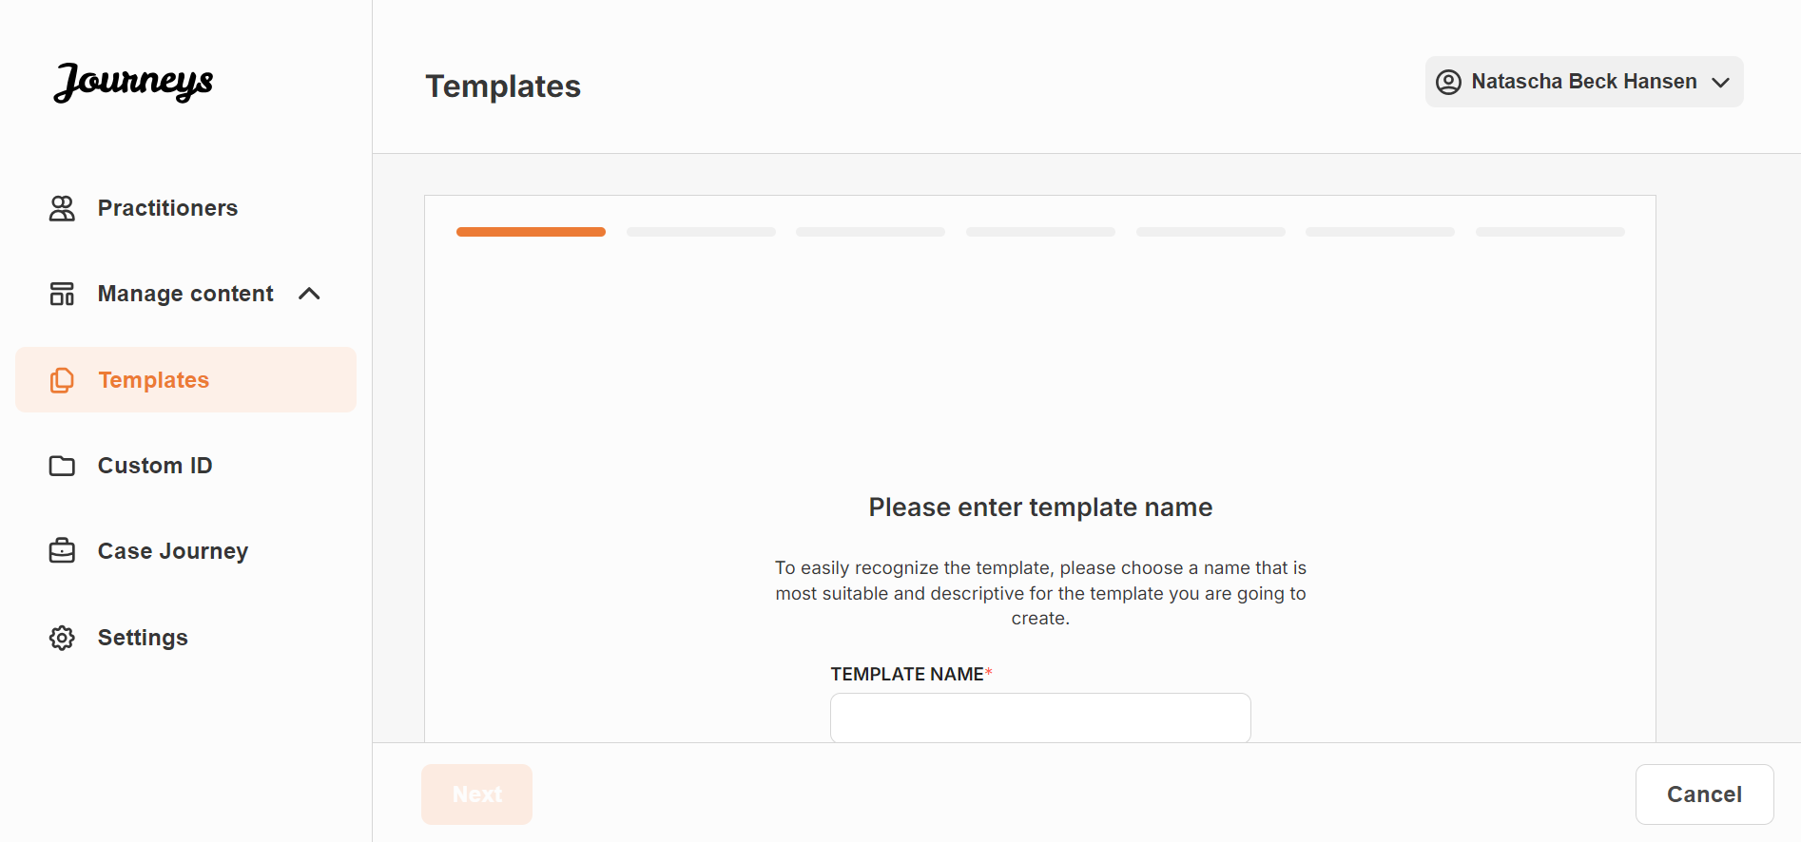
5. Select the content that you would like to include in this template – all content you have added in the previous steps will be shown to you at once, it’s important to have a clear system to distinguish between different versions of the same content.
- Select the content that you would like to include about your Barnahus by clicking the boxes of the content that you would like to include. | 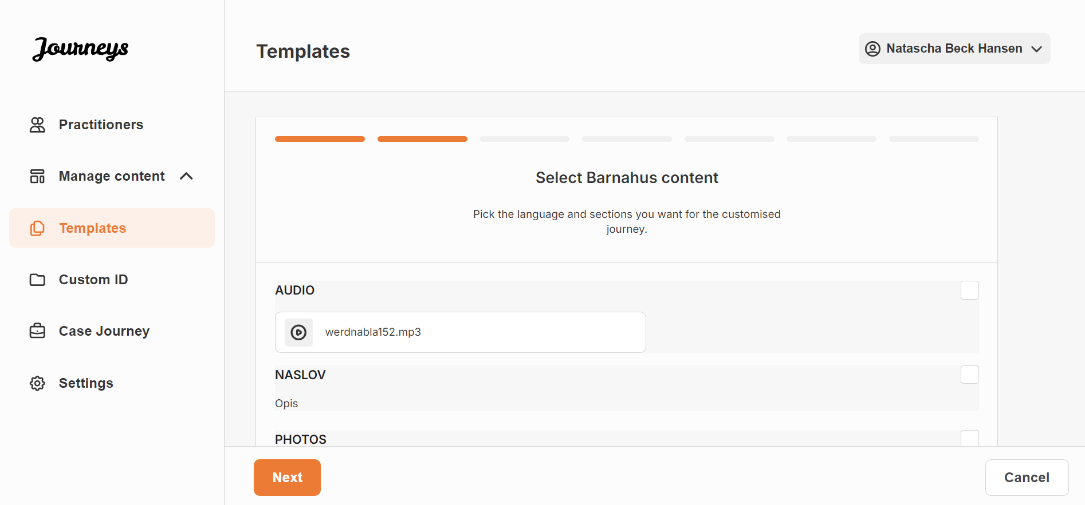
- Select the order you would like to showcase the rooms or if you want to remove one of the rooms for this template. | 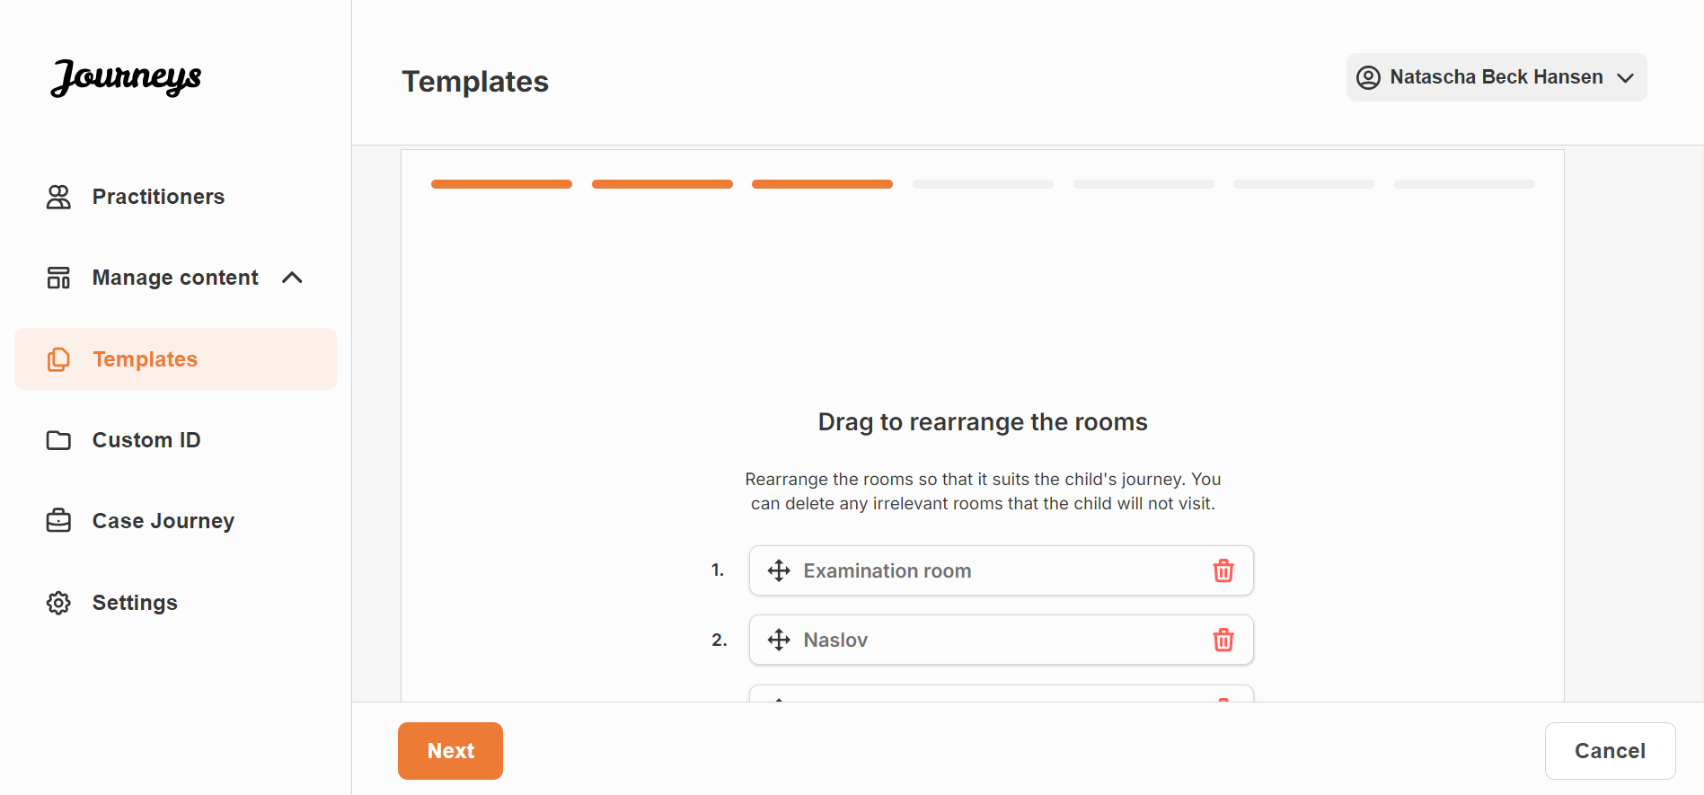
- Select the content that you would like to include about the rooms by clicking the boxes of the content that you would like to include. | 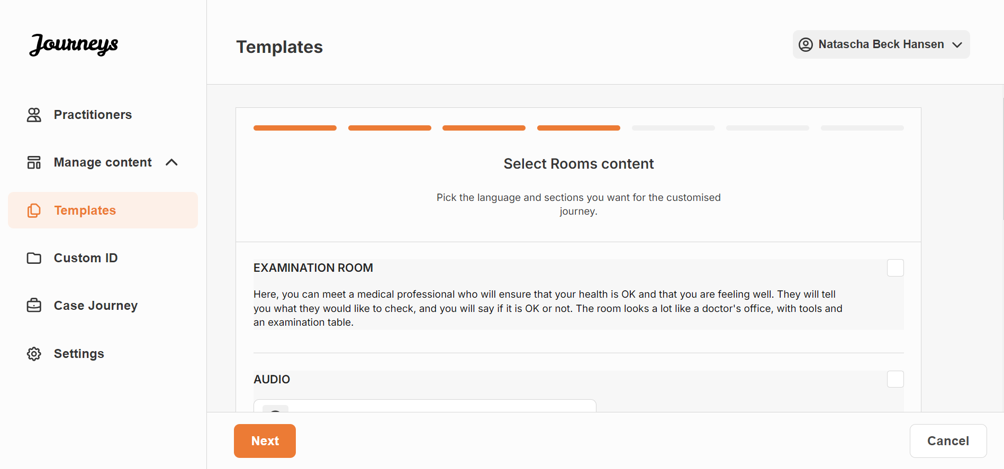
- Select the content that you would like to include about the staff by clicking the boxes of the content that you would like to include. | 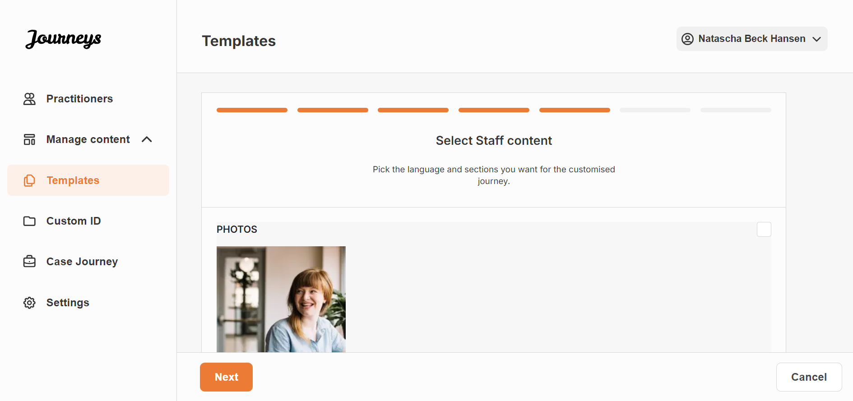
6. Preview your template and save.  You can create as many templates as you want. | 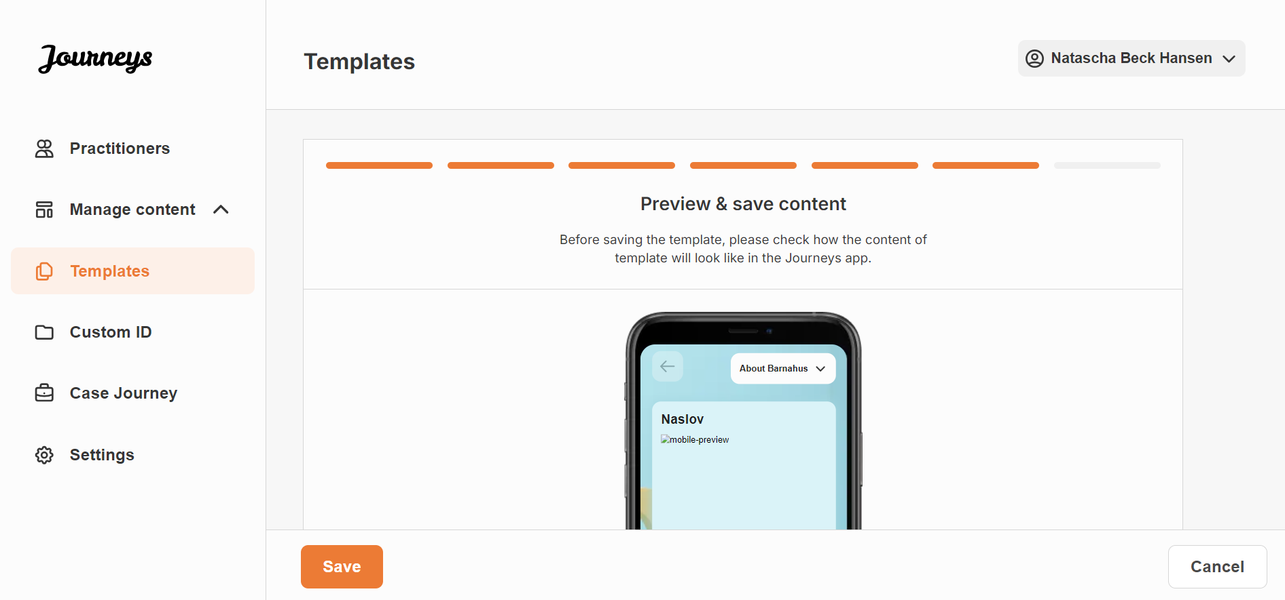

Creating a Custom ID
In order to create a custom journey for a child, you must first create a unique custom ID in the dashboard. After you’ve created the custom ID, you link the journey that you want to create to this ID. The Custom ID also serves as a first-time passcode for the child to access their custom journey in the app.
See the video tutorial here: https://www.youtube.com/watch?v=XvPmtSYWiOU
1. Navigate to the “Custom ID” section.  2. Select “Add Custom ID” | 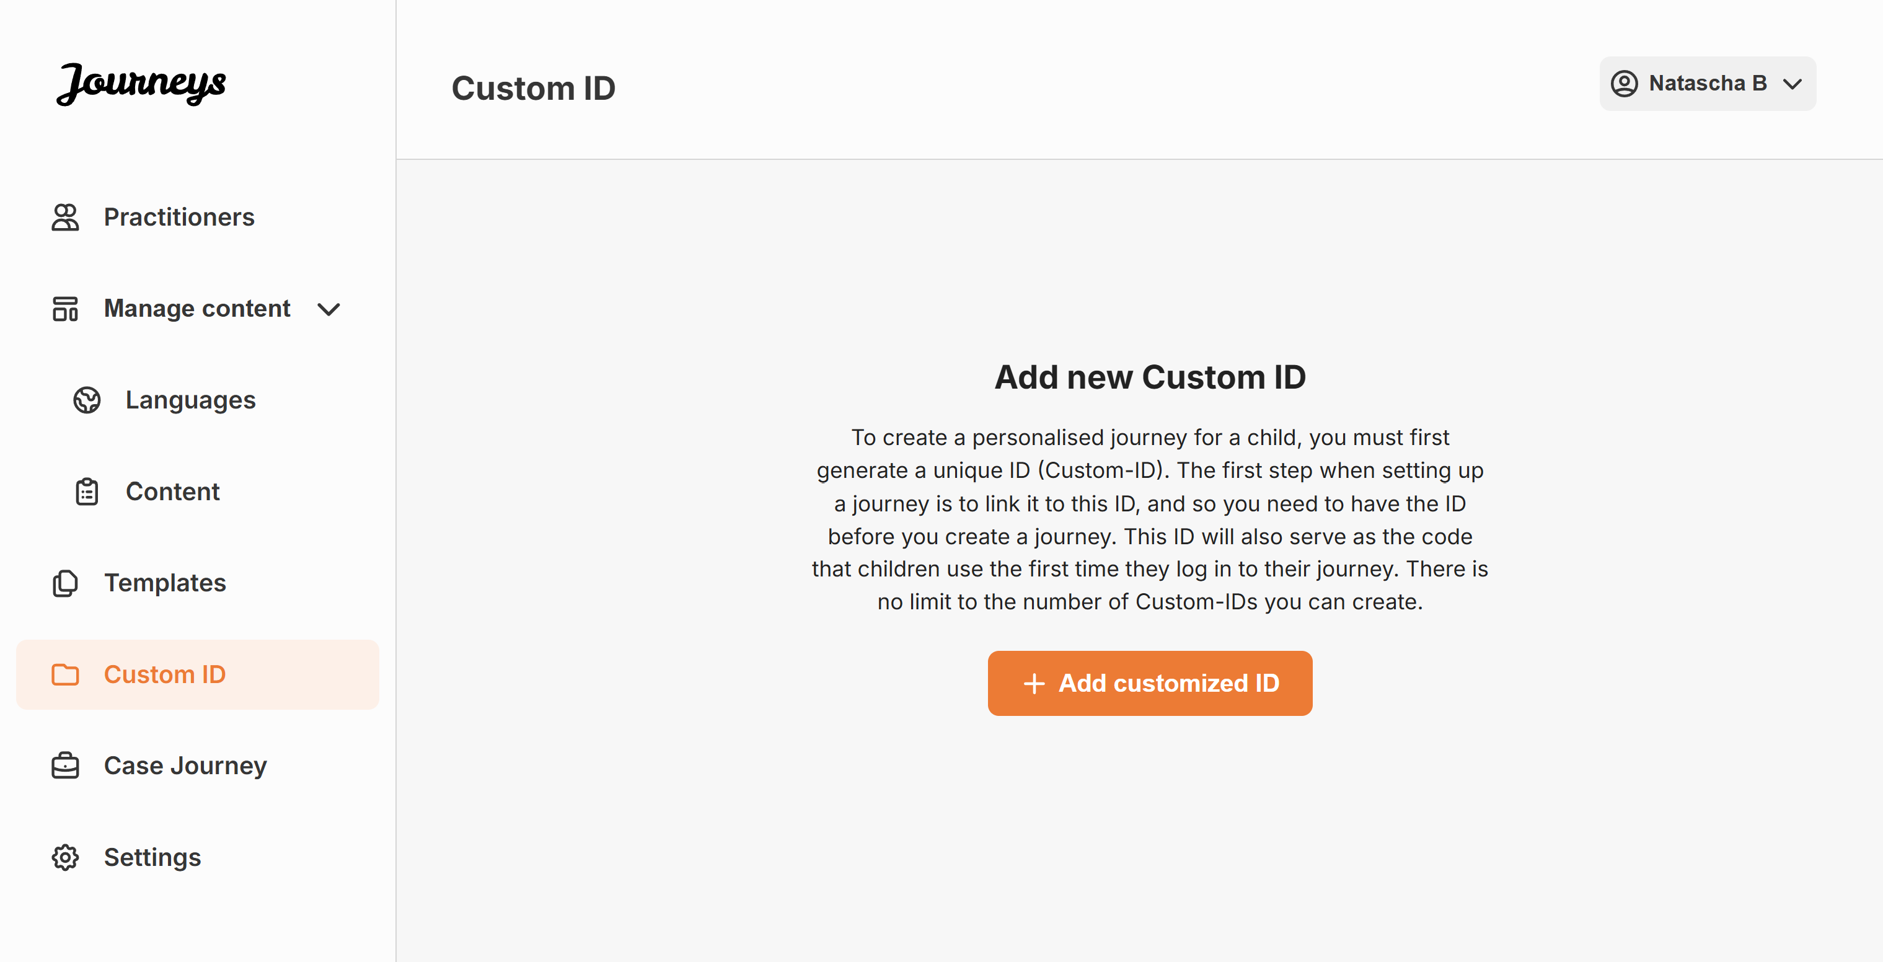
3. Come up with a distinct/identifiable but appropriate Custom ID for the child that you want to create a personalised journey for. This Custom ID will serve as a one-time passcode for the child to access their journey in the app – after the child has logged in for the first time, they will be prompted to change their access code. | 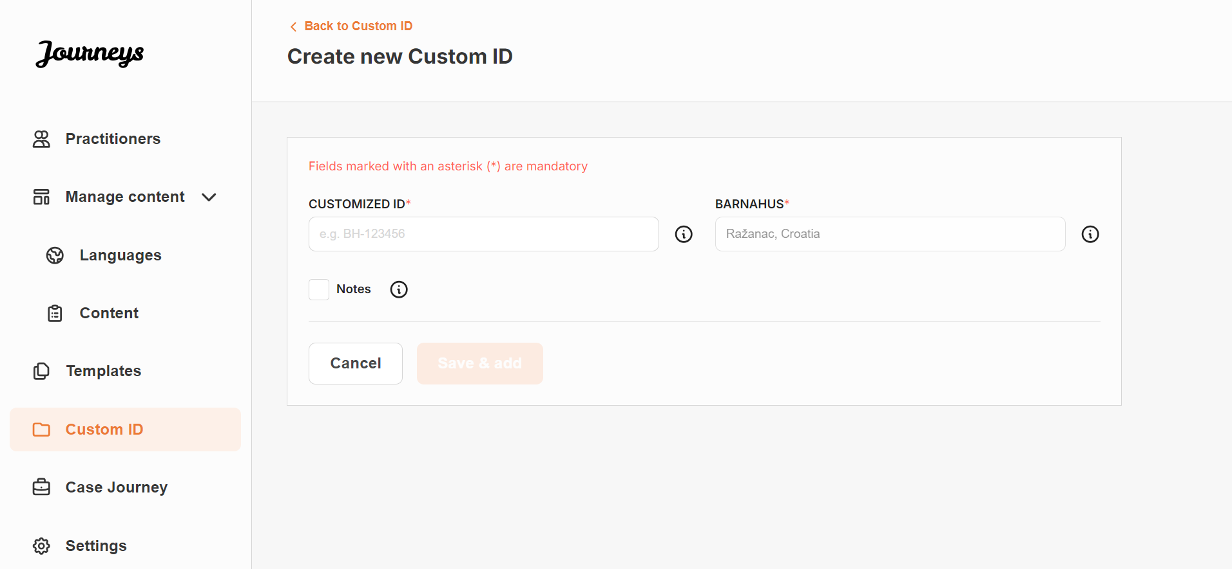
4. Enable/disable notes depending on the local/national context and when you would like for the child to be able to leave private comments about the Barnahus, rooms or staff – this can be enabled/disabled at any time.

Creating a Custom Journey for a child
Rearrange the rooms, and tailor the language and the content you want to show, to create a custom journey for the child. The child will access their custom journey on a mobile/tablet app by entering the Barnahus ID and the Custom ID.
See the video tutorial here: [Insert YouTube URL]
1. Navigate to the “Custom Journey” section  2. Select “Create Custom Journey”  3. Select the Custom ID that you would like to create a custom journey for. | 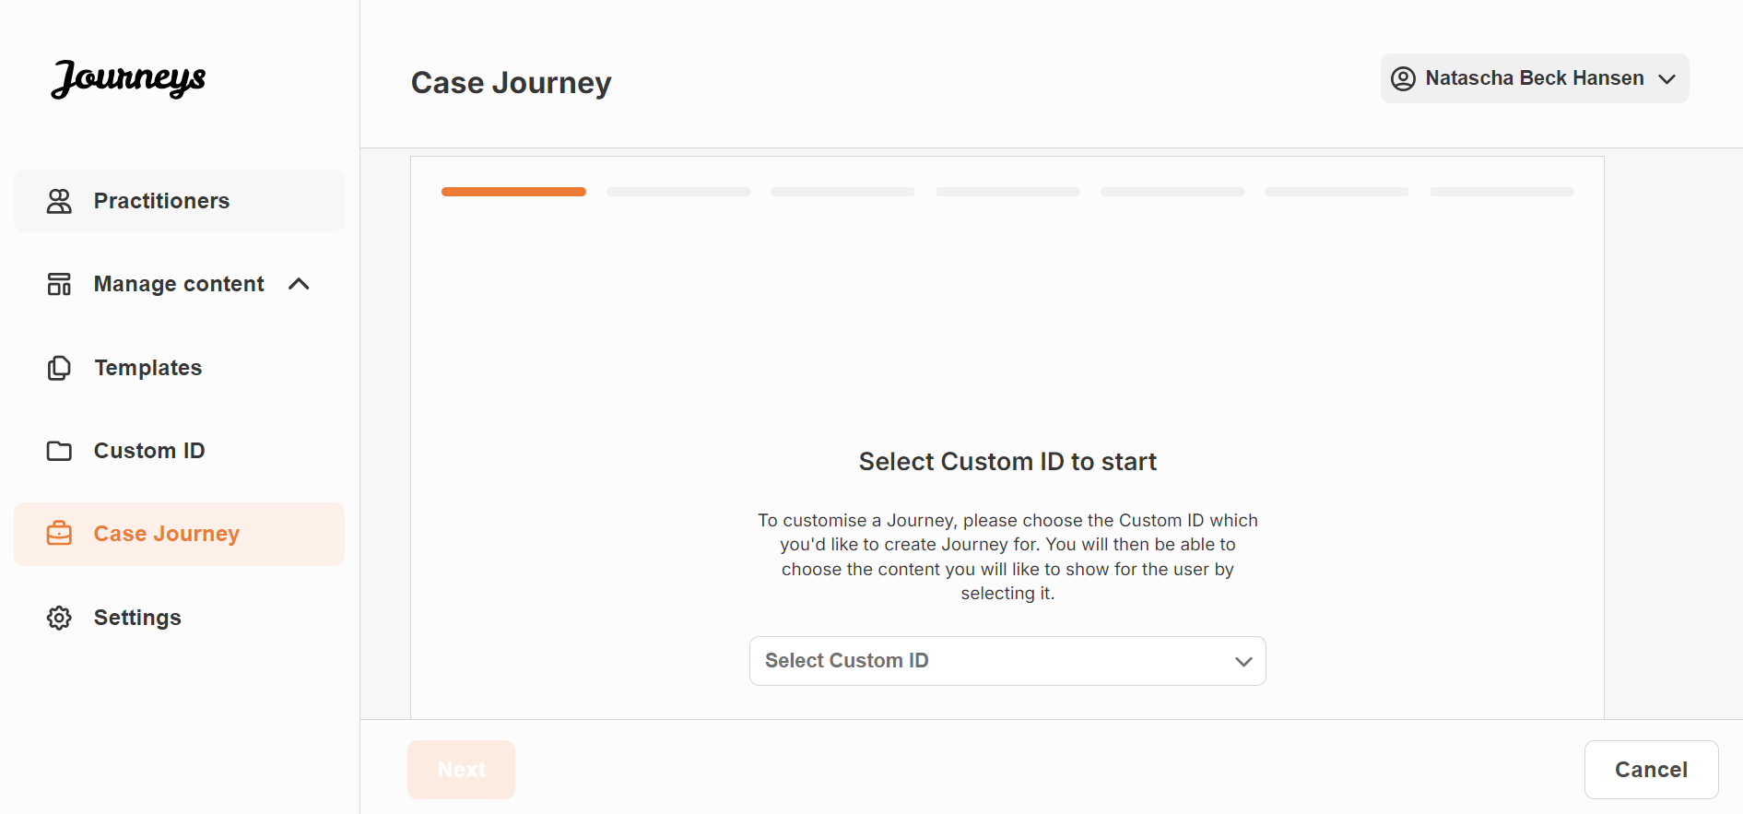
4. Select the language you would like to create the custom journey in. | 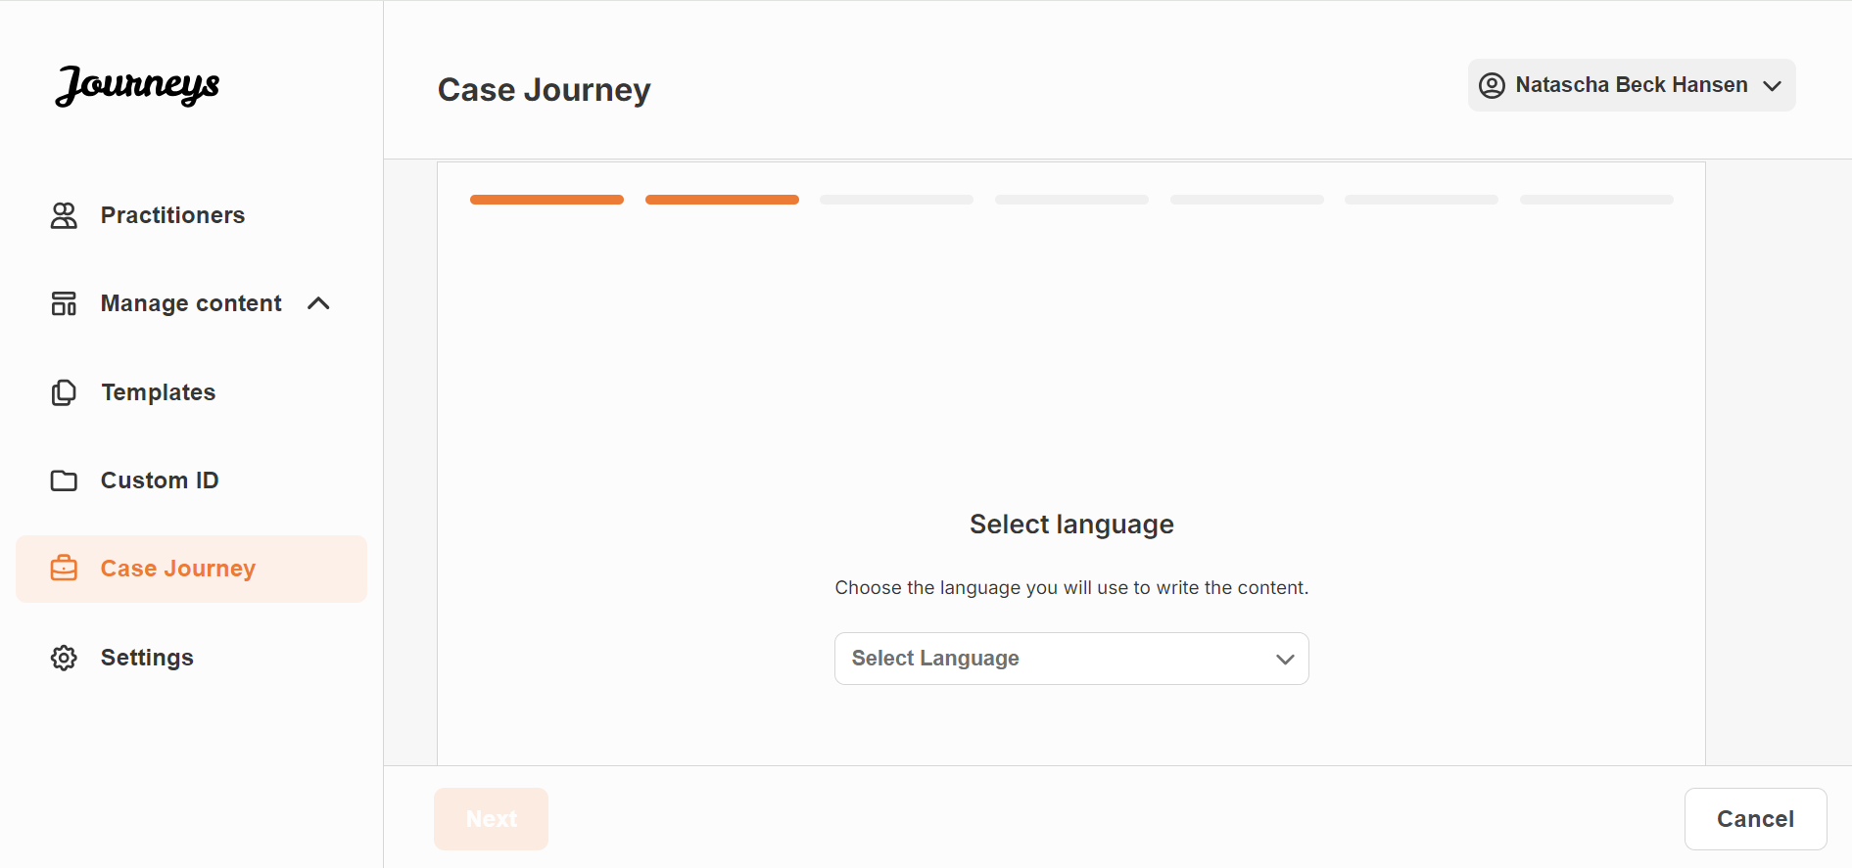
5. Select if you’d like to create the journey from a template or if you’d like to create it from scratch. | 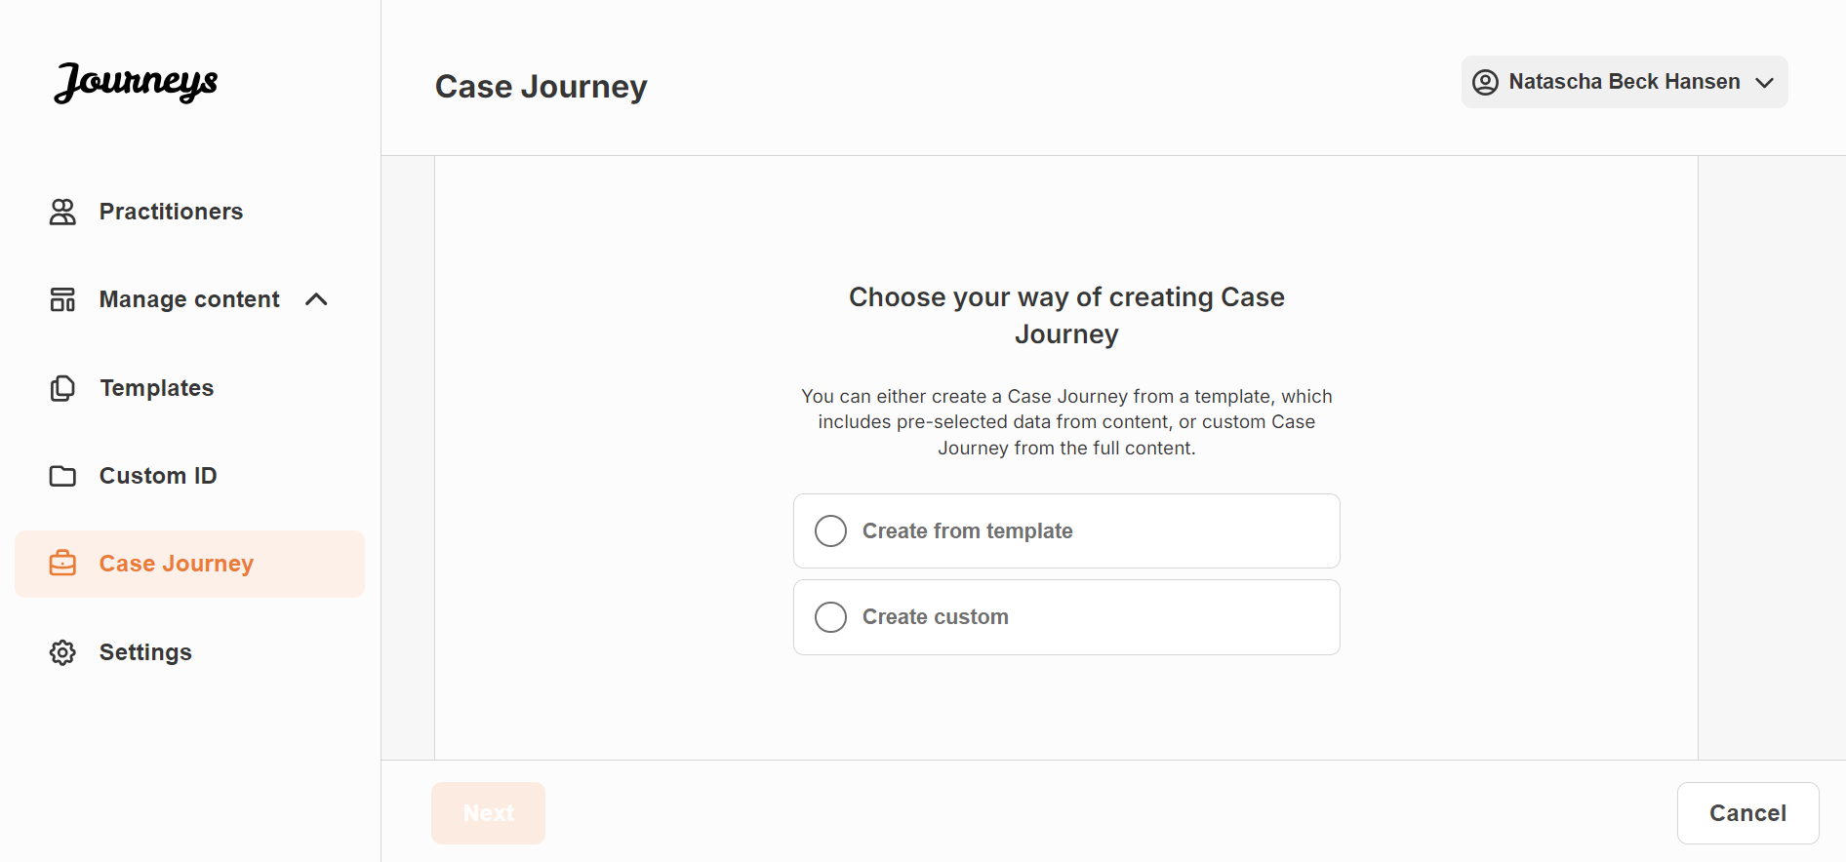

Create a journey from a template
If you’ve created a template, you can choose “Create from template” when you’re creating a Custom Journey for a child. This will automatically create the journey for you.
1. Select the template that you would like to use. | 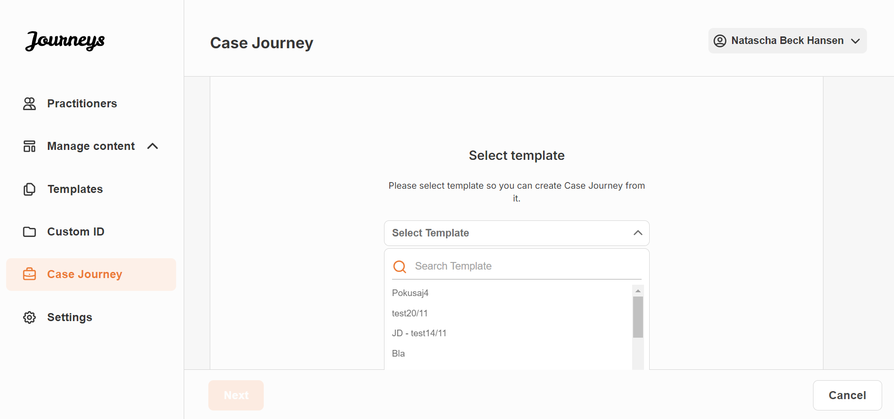
2. Choose if you’d like to use the template as is (“Use a ready-made template”,) or if you want to customise it further (“Customise template”). | 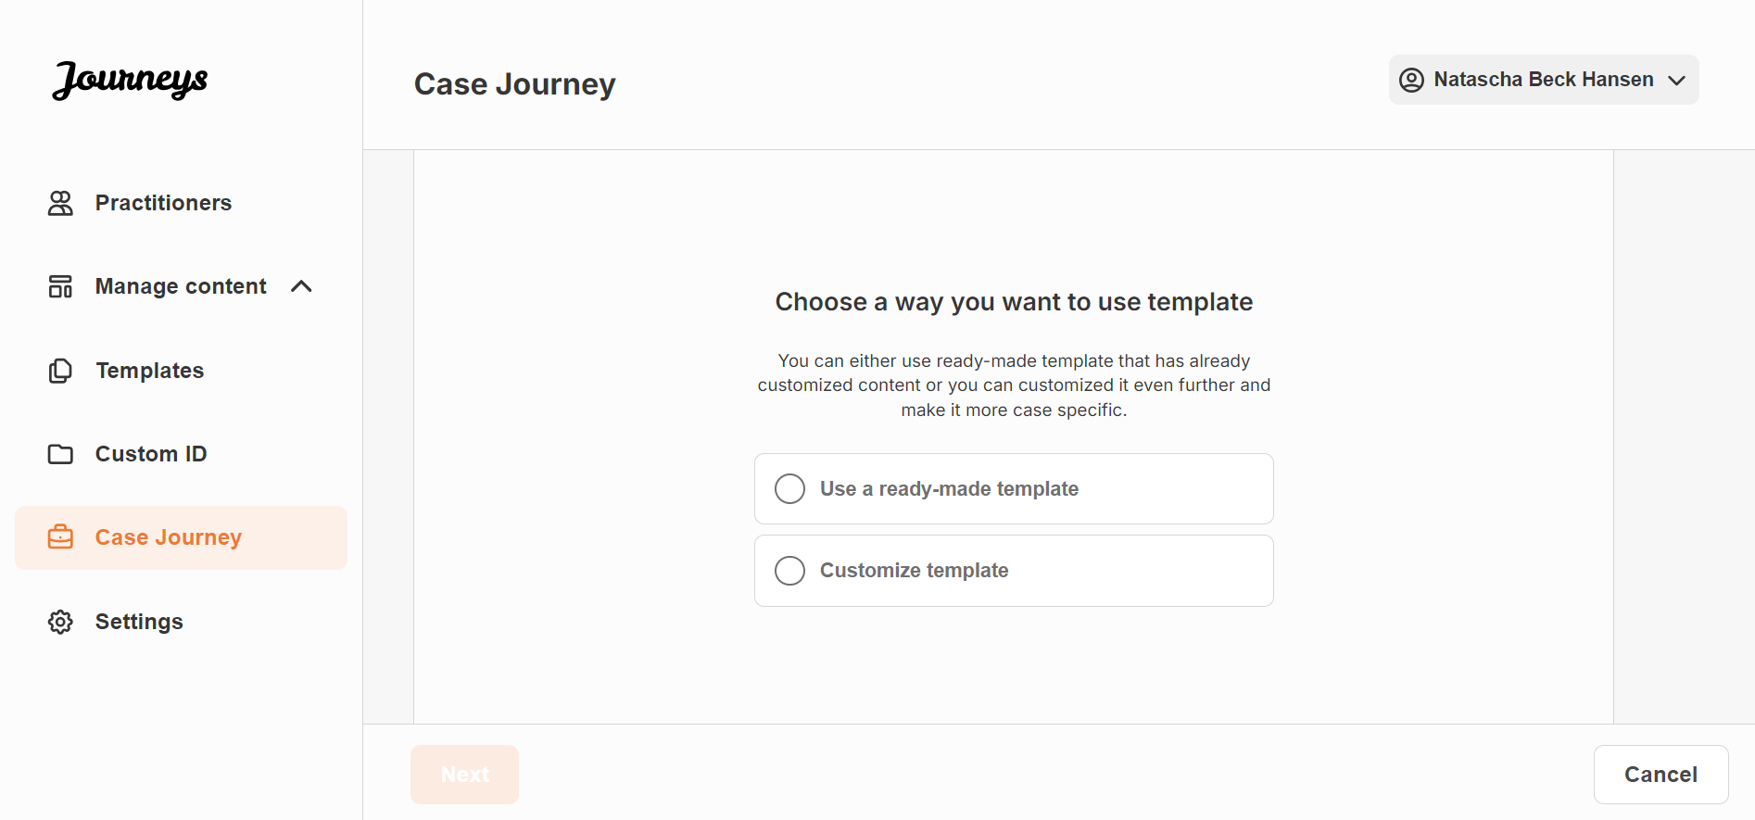
Use ready-made template:
If you choose to use a ready-made template you are automatically redirected to the last step to preview and save the custom journey – all information about the Barnahus, rooms and staff will be shown as it is in the template. | 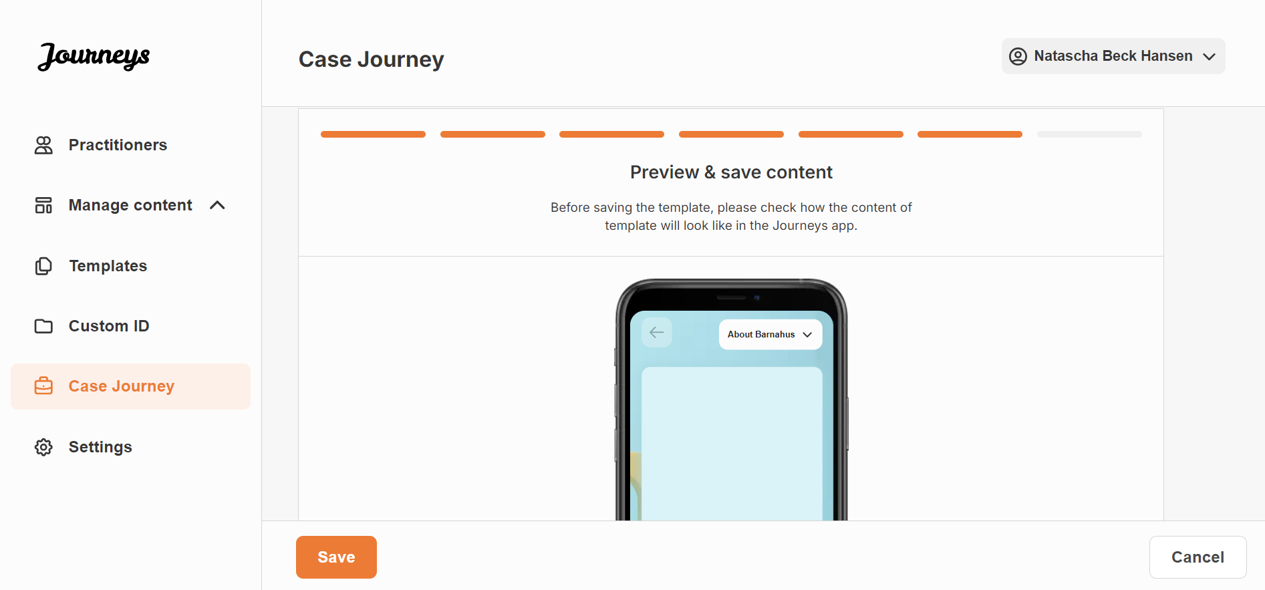
Share the Barnahus ID (which serves as a username) and the Custom ID with the child for them to be able to access their tailored journey on the mobile app. The Barnahus ID can be found…
Customise template:
If you choose to customise the template, you are able to further limit what is shown to the child. For example, if you know that the child will not meet certain staff during their Journey, you can customise the template for this journey to not show that staff.
Please note that you cannot add more information than shown in the template, only narrow it further.
1. Select the content from the template that you would like to include in this custom journey. | [Insert images]
2. Preview and save.
Share the Barnahus ID (which serves as a username) and the Custom ID with the child for them to be able to access their tailored journey on the mobile app. The Barnahus ID can be found…
Create custom journey from scratch (“Create Custom”)
Creating a Custom Journey from scratch follows the same process as when you are creating a template. You are presented with all the information that was added when setting up the content for the app, and you pick and choose what rooms, staff, and information you would like to include in the journey.
Again, it is important to have a clear system to distinguish between different versions of the same content.
1. Select the content that you would like to include in this journey:
- Select the content that you would like to include about your Barnahus by clicking the boxes of the content that you would like to include.
- Select the order you would like to showcase the rooms or if you want to remove one of the rooms for this journey.
- Select the content that you would like to include about the rooms by clicking the boxes of the content that you would like to include.
- Select the content that you would like to include about the staff by clicking the boxes of the content that you would like to include.
6. Preview the journey and save.
Share the Barnahus ID (which serves as a username) and the Custom ID with the child for them to be able to access their tailored journey on the mobile app. The Barnahus ID can be found…
Create a journey to be shared with multiple children
In order to create a Journey that can be shared with multiple children, you simply need to create a Custom ID that has notes disabled – and create a Journey from that template. You are then able to share the Barnahus ID and Custom ID for this Journey with multiple children.
The children viewing this Journey will not be able to leave any comments, nor will they be able to change the password to access the Journey (which would have locked out other children from viewing this journey)

Admin Onboarding
The Admin is added to the dashboard by the Master Admin.
Your role is to invite other contributors to the dashboard (Practitioners) and manage the content for the app – i.e. adding information and pictures about your Barnahus, the different rooms and staff. You also have the ability to create custom IDs and custom journeys for the children visiting your Barnahus.
Adding a practitioner grants them limited rights to create custom journeys for children.

Accessing Your Admin Dashboard
1. Accept the invitation email and log in to your Admin dashboard.
2. Familiarise yourself with the dashboard interface and available functionalities.

Inviting Practitioners
Adding a practitioner grants them limited rights to create custom journeys for children, they are not able to add any new content but can use the content that has been set up by the Master Admin and the Admins.
See the video tutorial here: [Insert YouTube URL]
1. Navigate to the ‘Practitioners’ tab in the side menu.  2. Click “Add Practitioner” | 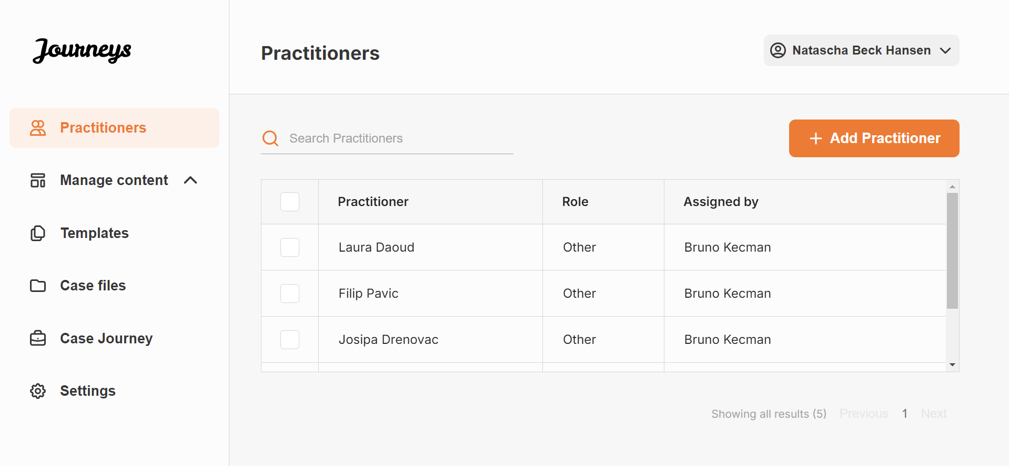
3. Fill in the required details (email, first name, last name, role) for each Practitioner – adding a phone number is optional.  The Barnahus location is pre-determined and cannot be changed as you can only add practitioners to the Barnahus that you are assigned to. | 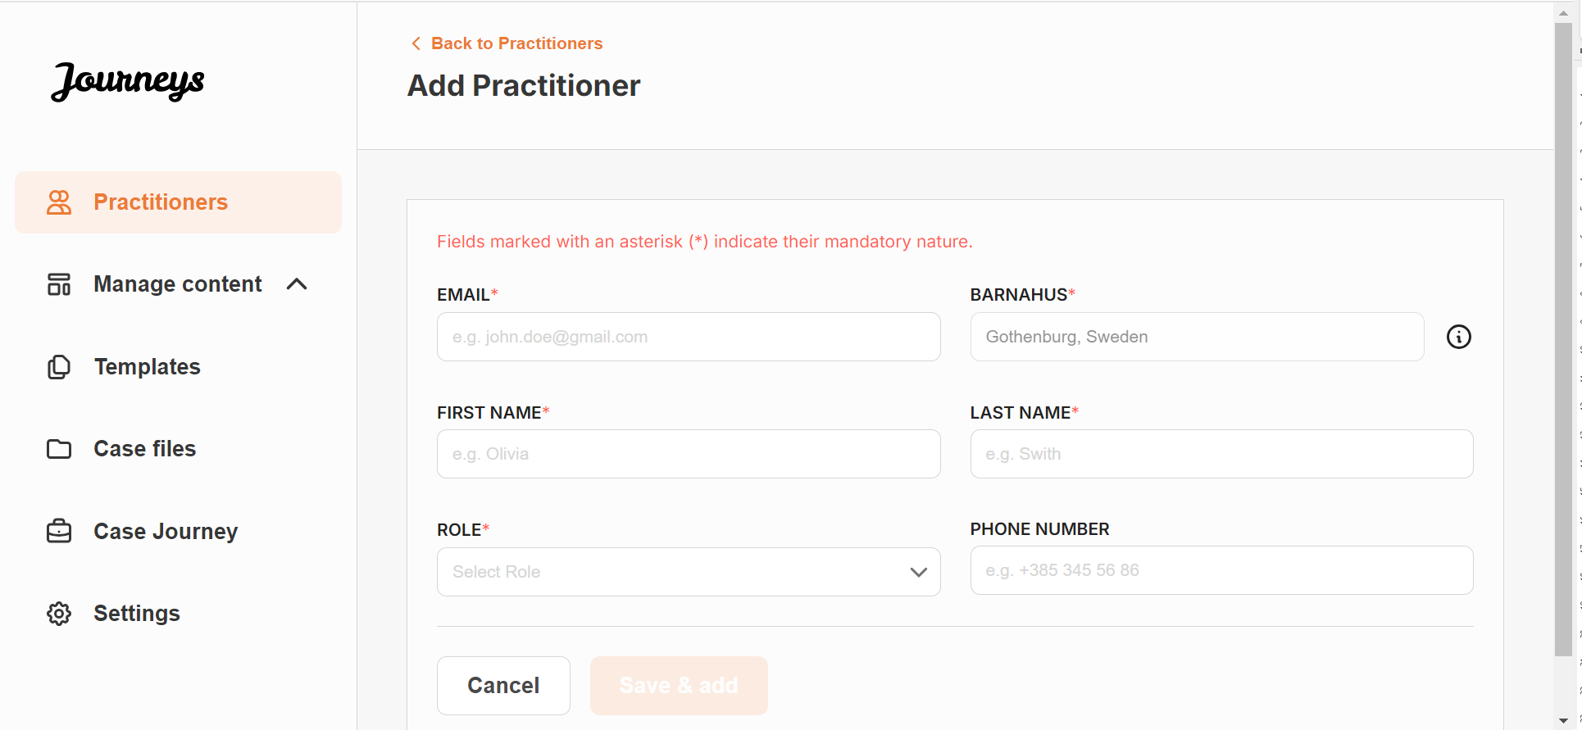
4. Click “Save & add” to send the invitation email to the Practitioner.

Creating templates
To streamline the process of designing a custom journey for a child, you can create templates using the content you have added. Templates serve as a starting point, simplifying the creation of custom journeys – you can use the created templates as many times as you’d like.
After a template is created, it can be used to build a custom journey for the child and make further adjustments as needed. This flexible approach ensures that the journey meets the unique need of the child, while also saving time during the planning process.
Example:
If you’ve added additional versions of your text tailored to different age groups — e.g. 3–9 years and 10–17 years — you can create separate templates for each group. For instance, you might create a template containing all the text designed for the younger age group.
Additionally, if there are typical cases in your Barnahus where only certain rooms are visited, you can create a template that only includes those rooms, rather than all available rooms.
Another example of how you can use templates is if you’d like to provide the same informative journey to multiple children showing all the rooms and staff in your Barnahus. In this instance, you can create a so called generic template – or two if you have provided text for different age groups. We will go through how to create a journey that can be shared with multiple children under the heading “Create a Custom Journey” on page [insert page].
See the video tutorial here: [Insert YouTube URL]
1. Navigate to the “Templates” tab in the side menu
2. Click on “Add template” – Please note that you cannot create a template before you have added content about your Barnahus
3. Select the language that you would like to create a template for
4. Name your template.
We recommend naming it something that is easily identifiable for other practitioners in your Barnahus as well (e.g. “3-9 Y/O Barnahus Journey”, “10-17 Y/O Journey without Examination room” etc.)

5. Select the content that you would like to include in this template – all content you have added in the previous steps will be shown to you at once, it’s important to have a clear system to distinguish between different versions of the same content.
- Select the content that you would like to include about your Barnahus by clicking the boxes of the content that you would like to include.
- Select the order you would like to showcase the rooms or if you want to remove one of the rooms for this template.
- Select the content that you would like to include about the rooms by clicking the boxes of the content that you would like to include.
- Select the content that you would like to include about the staff by clicking the boxes of the content that you would like to include.
6. Preview your template and save.
You can create as many templates as you want.

Setting Up App Content
Populating the content of the app is one of your main responsibilities, including adding information and pictures about your Barnahus, the different rooms and staff tailored for different levels of maturity.
When you have added the content, you can preview how it will look it the app publishing it. You only need to upload the content in the desired language once, as the content added here will be the same for every child, i.e. general information that does not need to be changed for every child. If you wish to do so, you can add multiple versions of the same content (e.g. languages or age relative – easier or more elaborate text).
See the video tutorial here: [Insert YouTube URL]
Add languages
To set up the content about your Barnahus, you first need to add the languages that you would like to add content in. You do this in the ‘Languages’ tab under ‘Manage content’.  After clicking ‘Add language’, you need to search for the language that you would like to add and enable/disable auto-translation for the selected language. | 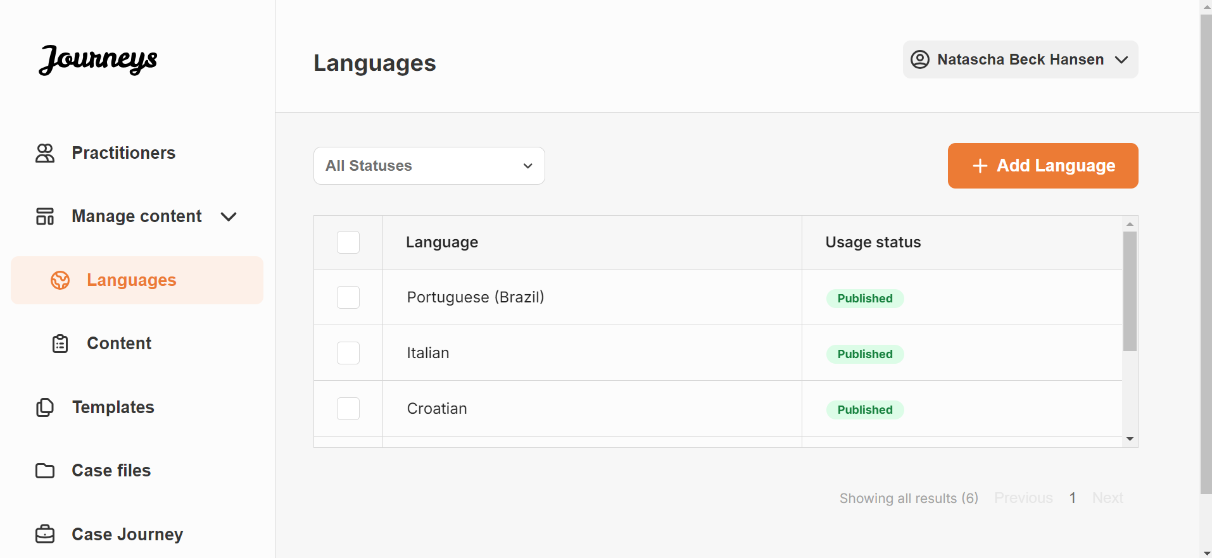
Auto-translate disabled: Having the auto-translate disabled adds the language to the system as a default language – this language will serve as the basis for every other translation.  Auto-translate enabled: Having the auto-translate enabled means that the content that you add in the default language, can be auto-translated to this other language through Google Translate. | 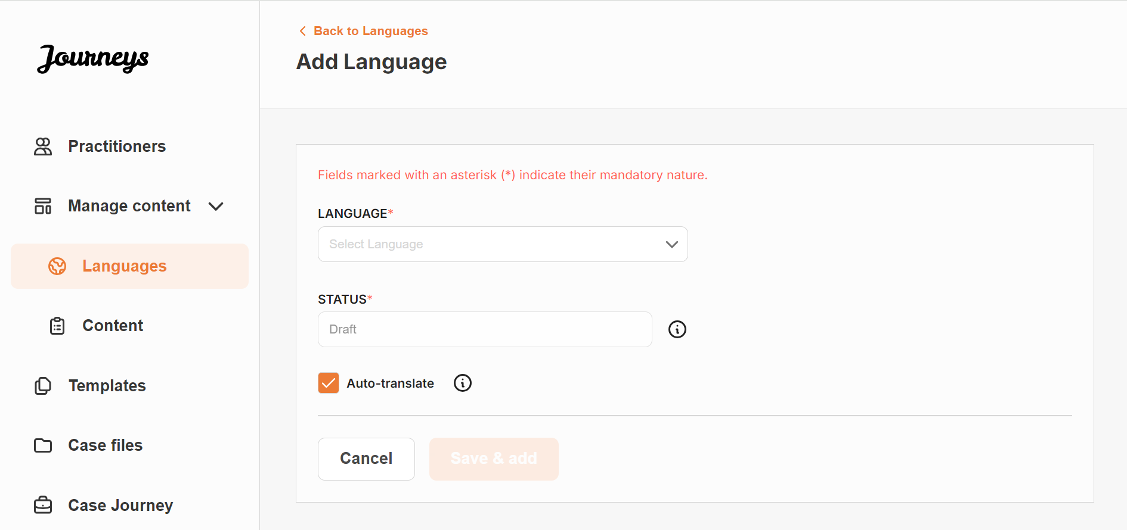
You can add as many languages as you’d like – you do not need to add all languages at once, you can always come back and add more later. We recommend that you start by just adding the default language.
The usage status in the overview showcases whether or not you have published any content in the different languages. Draft indicates that you have not yet published content in that specific language, whereas Published indicates that content has been published in that language.

Add content in default language
1. After you have added one your default language, navigate to the ‘Content’ tab under ‘Manage content’ and select the language that you have chosen as your default language.
2. You can add content in any order you’d like, but for the purpose of this user guide we will walk you through adding content in the order that is being shown in the dashboard: About your Barnahus, Rooms, and Staff.
- About Barnahus: When you click ‘Add About you Barnahus’ you will be asked to fill out information about your Barnahus that would be helpful for the child. Keep in mind that this will be the same for all the children, so keep it generic but helpful. |  | 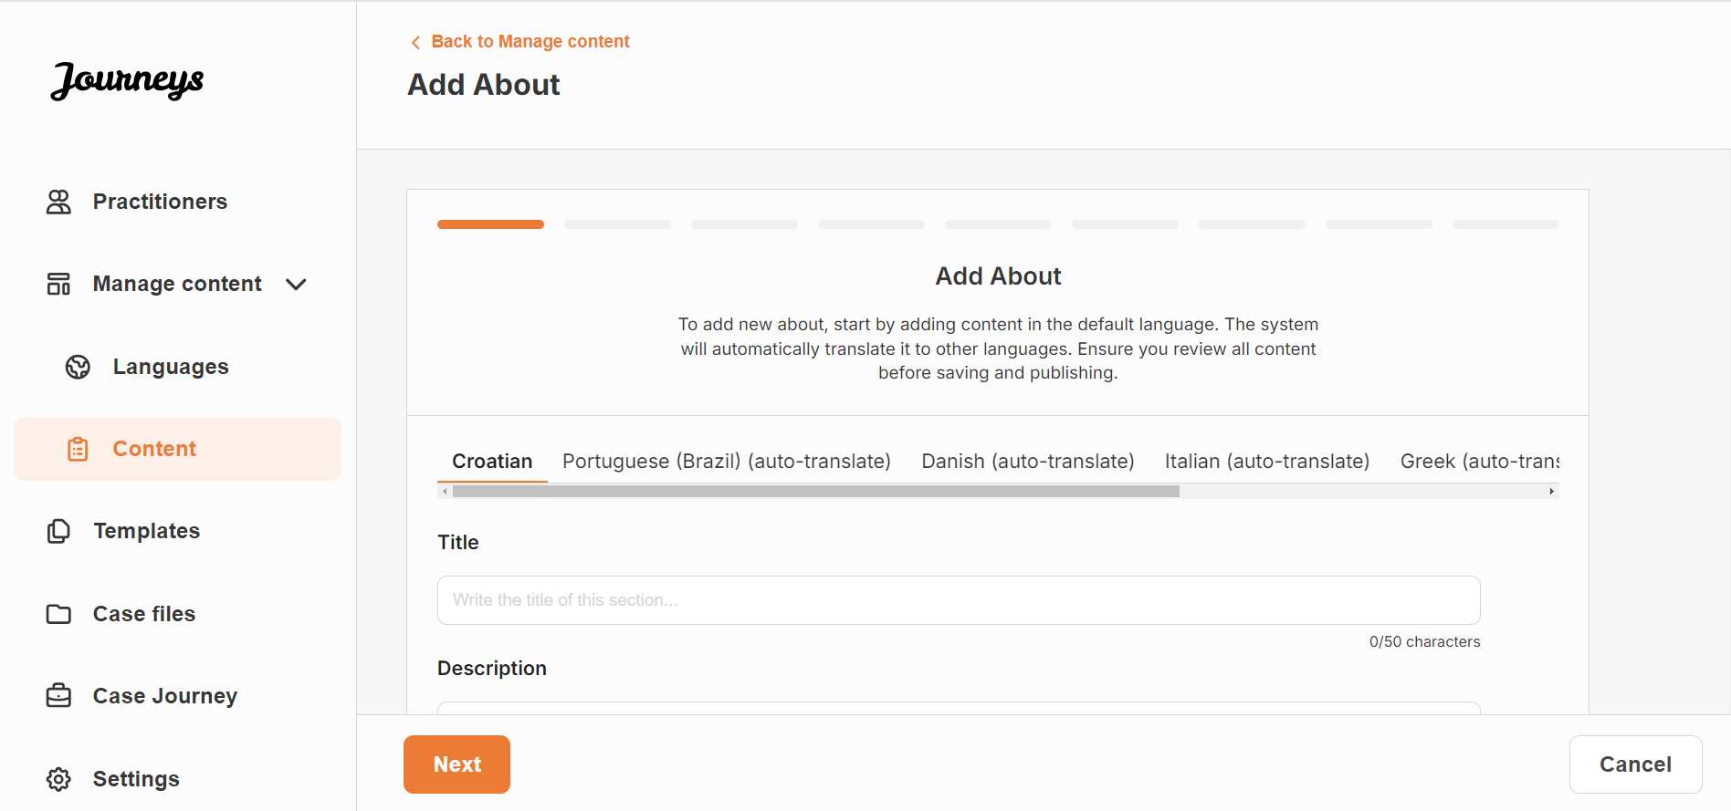
You can add multiple versions of ‘About your Barnahus’ in case you want to have different versions of the text tailored to different age groups. You can also add sections about what the child can expect during a visit, and what usually happens/can happen after the visit. |  | 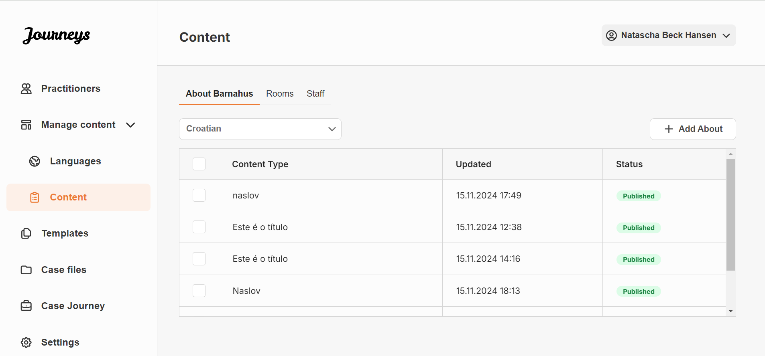
Examples of what you can write:
“About your Barnahus”  Barnahus is a safe and child-friendly place where children who are presumed victims of violence receive the support they need. At Barnahus, law enforcement, social services, physical health and mental health staff work together under one roof. By bringing the professions together and integrating how they work, children don't have to repeat their stories many times. | “What the child can expect”  At Barnahus, you will meet professionals from law enforcement, social services, physical health and mental health, that will provide you support throughout the day. |  | “What happens after the visit”  After your visit to Barnahus, you’ll receive ongoing support focused on helping you feel your best.

- Rooms: When you click ‘Add Rooms’ you will be asked to fill out information about the different rooms in your Barnahus and what usually happens in these different rooms, as well as add photos of the rooms if you’d like. Keep in mind that this will be the same for all the children, so keep it generic but helpful. |  | 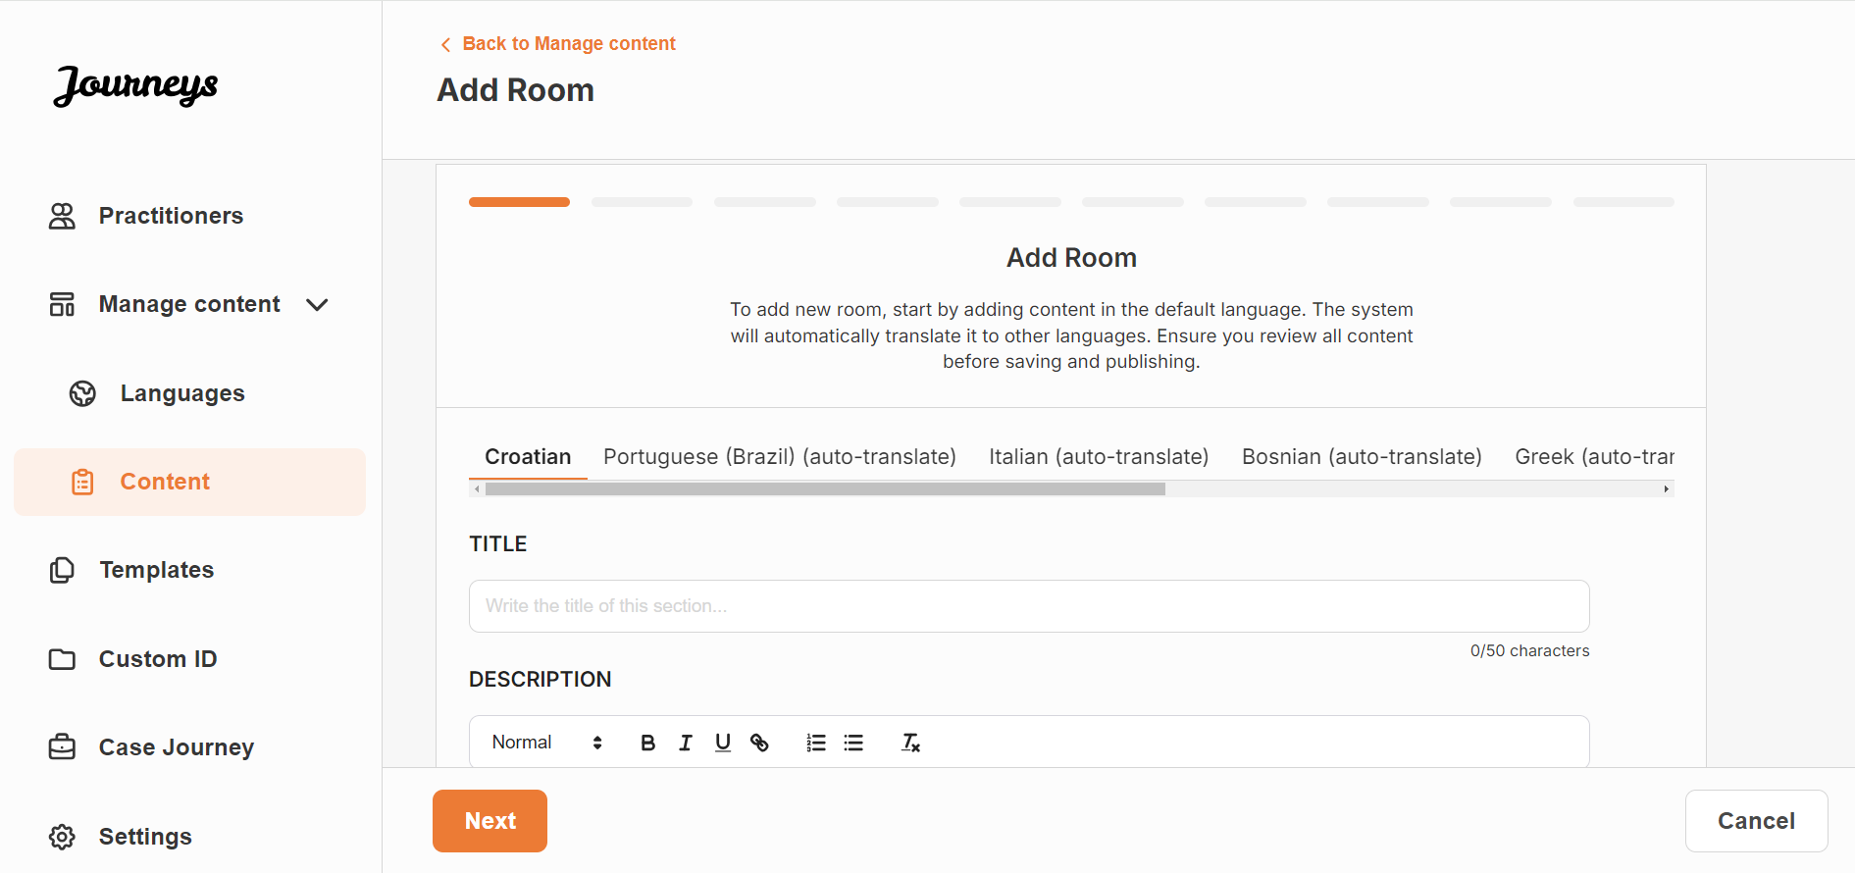
You can add multiple versions of ‘Rooms’ in case you want to have different versions of the text tailored to different age groups. |  | 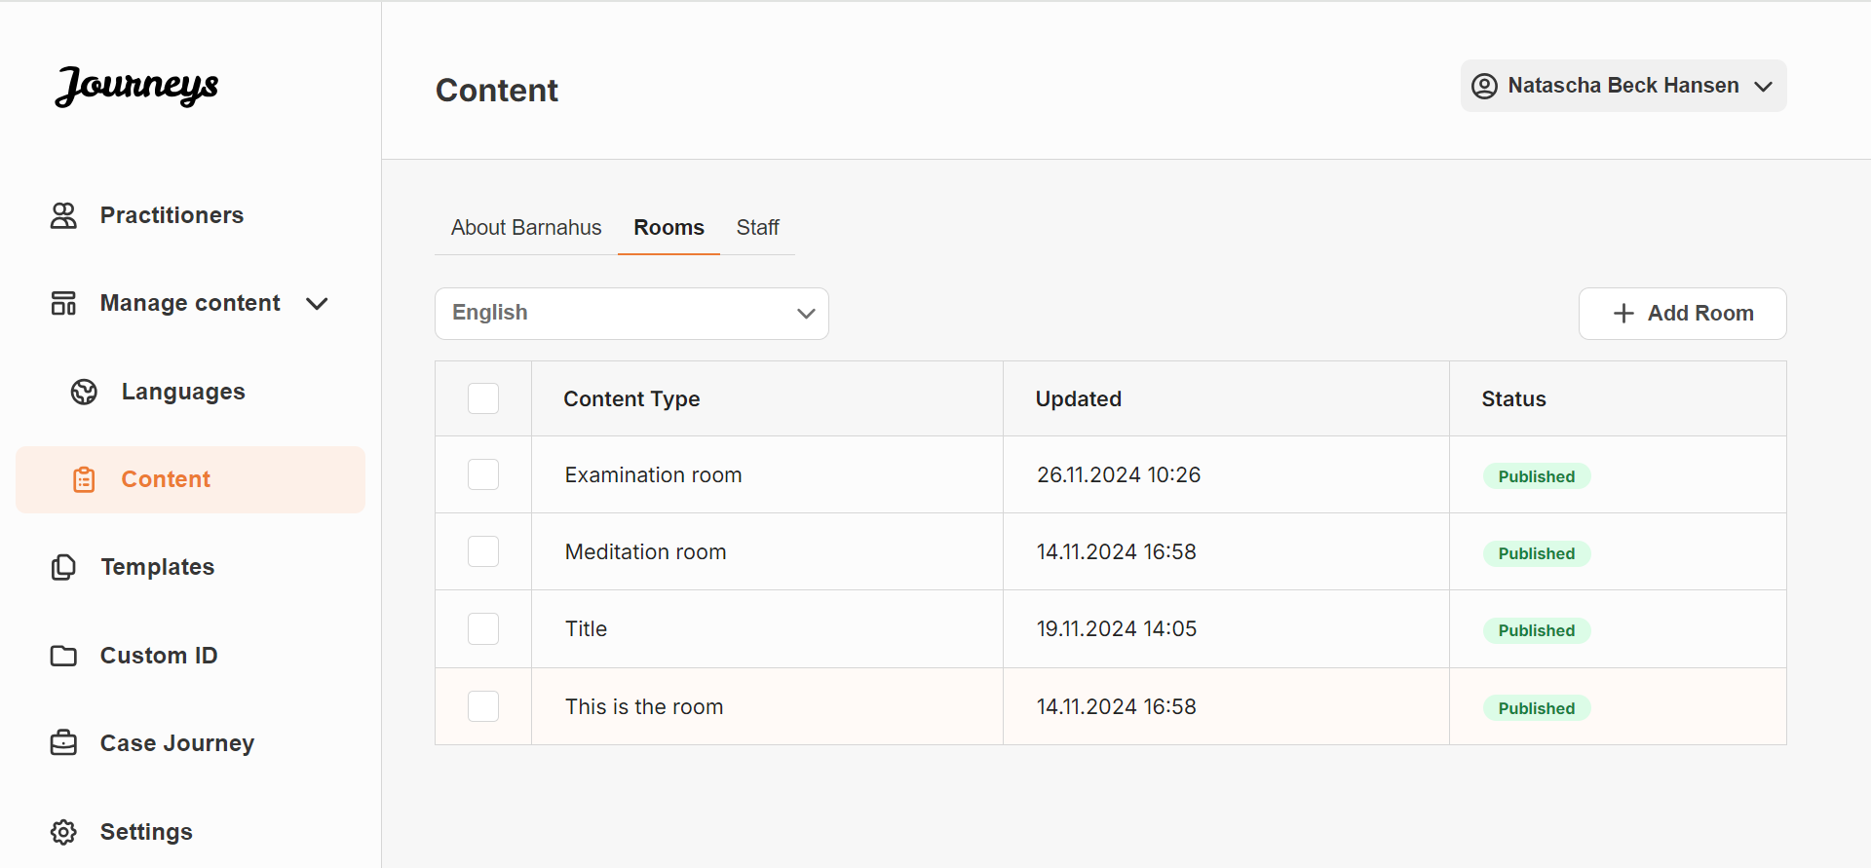
Examples of what you can write:
“Waiting room”  You wait in this soothing environment until an adult comes to take you to the next step in your appointment. There will be toys to play with and books to read. You can ask the people who work there any questions you have about your visit. | “Interview room”  In the interview room, you will talk with a professional who has a lot of experience in talking and listening to young people who may have been mistreated. They will give you instructions and ask questions. You can ask questions if you want, too. Your conversation will be recorded using cameras and microphones. This is so you don't have to be interviewed many times, and to ensure that everything is done correctly. |  | “Examination room”  Here, you can meet a medical professional who will ensure that your health is OK and that you are feeling well. They will tell you what they would like to check, and you will say if it is OK or not. The room looks a lot like a doctor's office, with tools and an examination table.

- Staff: When you click ‘Add Staff you will be asked to fill out information about the staff at the Barnahus.
You can add as many ‘Staff’ as you want. Keep in mind that you will need consent to add a photo from the staff in question.
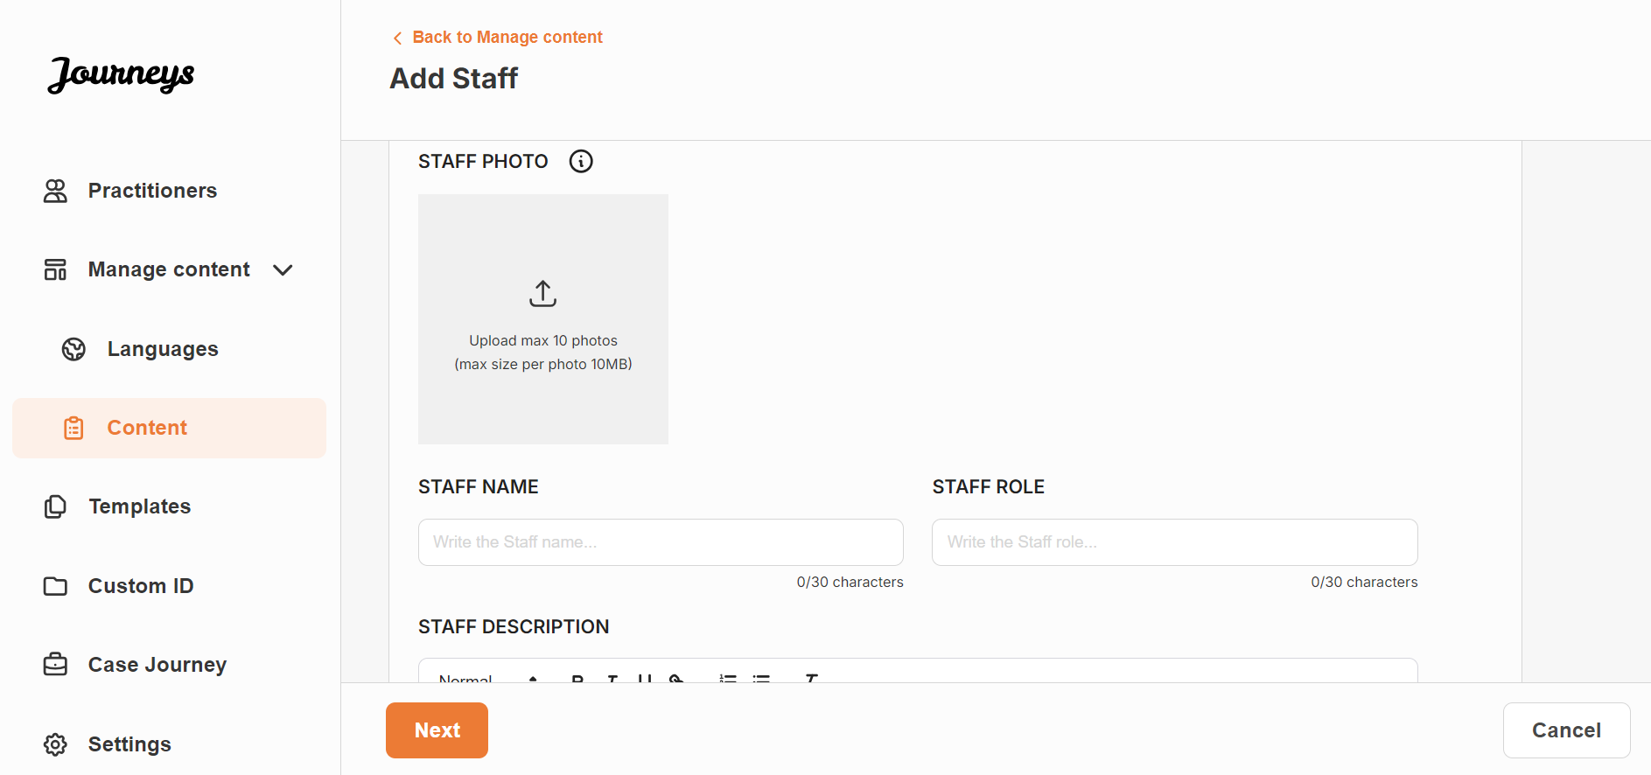 | 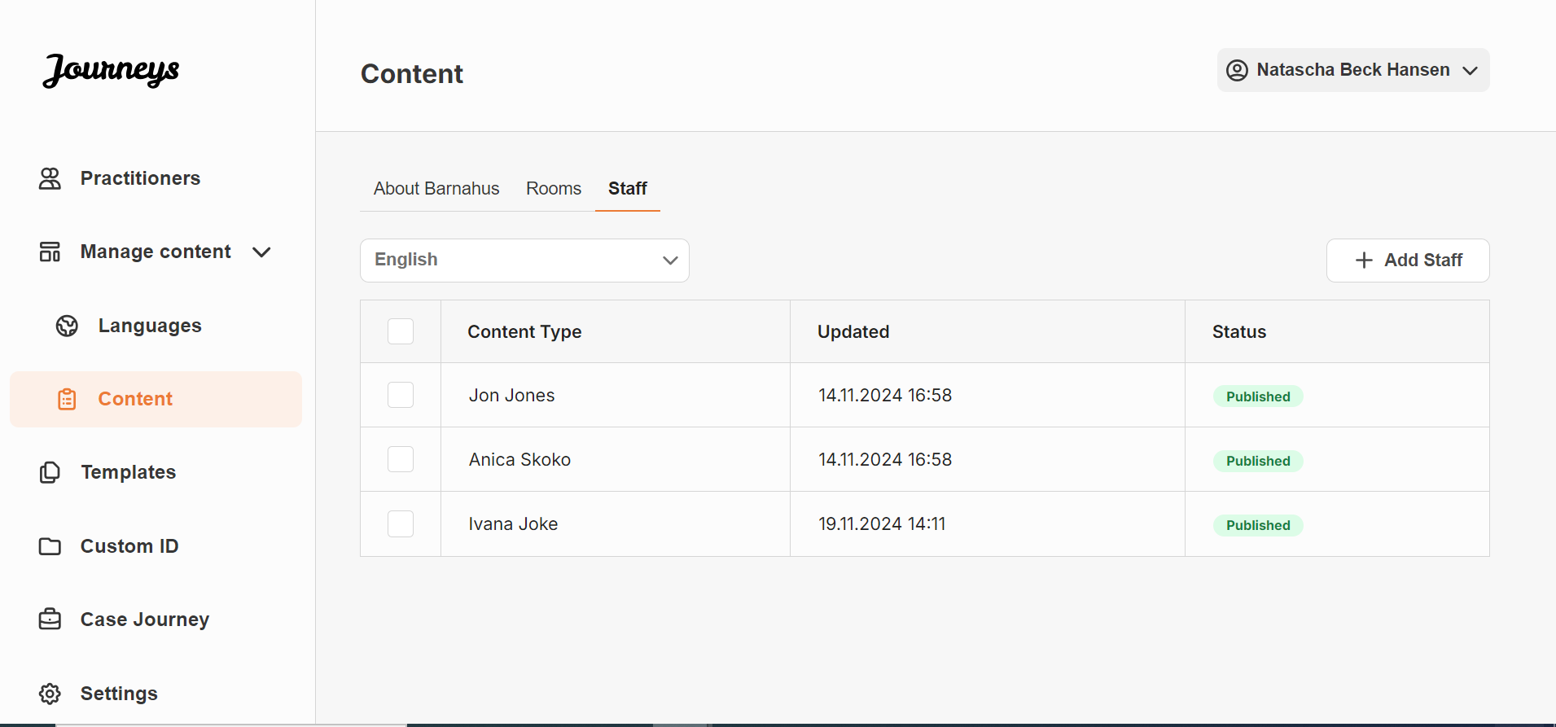
What you can write:
In the description for the staff, you can add anything that could be interesting for a child to know; this can be favourite foods, hobbies, talents and so on. Anything that would humanise the staff for a child that may be scared about meeting new adults.

3. For each ‘About’, ‘Room’ and ‘Staff’ that you add, make sure to preview the content before publishing it to see how it will look in the mobile app.
4. Create auto-translated content in another language based on the information that you have just provided – the auto-translation is generated by Google and needs to be manually checked for mistakes before publishing.
Add content in an auto-translated language
1. Once you have added content in the default language you can go back to the languages tab and add other languages with auto-translation enabled. We recommend that you add all the languages that you expect to use for auto-translation at this stage.
2. Navigate to the ‘Content’ tab under ‘Manage content’ and in the drop-down menu, select the language that you would like to add auto-translated content in.
3. When you click ‘Review & add Content’ you will be shown the auto-translated version of the content that you added in the default language.

Go through the translation and make changes where necessary.
4. Preview how the content will look in the app and publish.
5. Once you have published the translated content, you can choose to review another auto-translated language.

Creating a Custom ID
In order to create a custom journey for a child, you must first create a unique, custom ID in the dashboard. After you’ve created the custom ID, you link the journey that you want to create to this ID. The Custom ID also serves as a first-time passcode for the child to access their custom journey in the app.
See the video tutorial here: [Insert YouTube URL]
1. Navigate to the “Custom ID” section.  2. Select “Create Custom ID” | 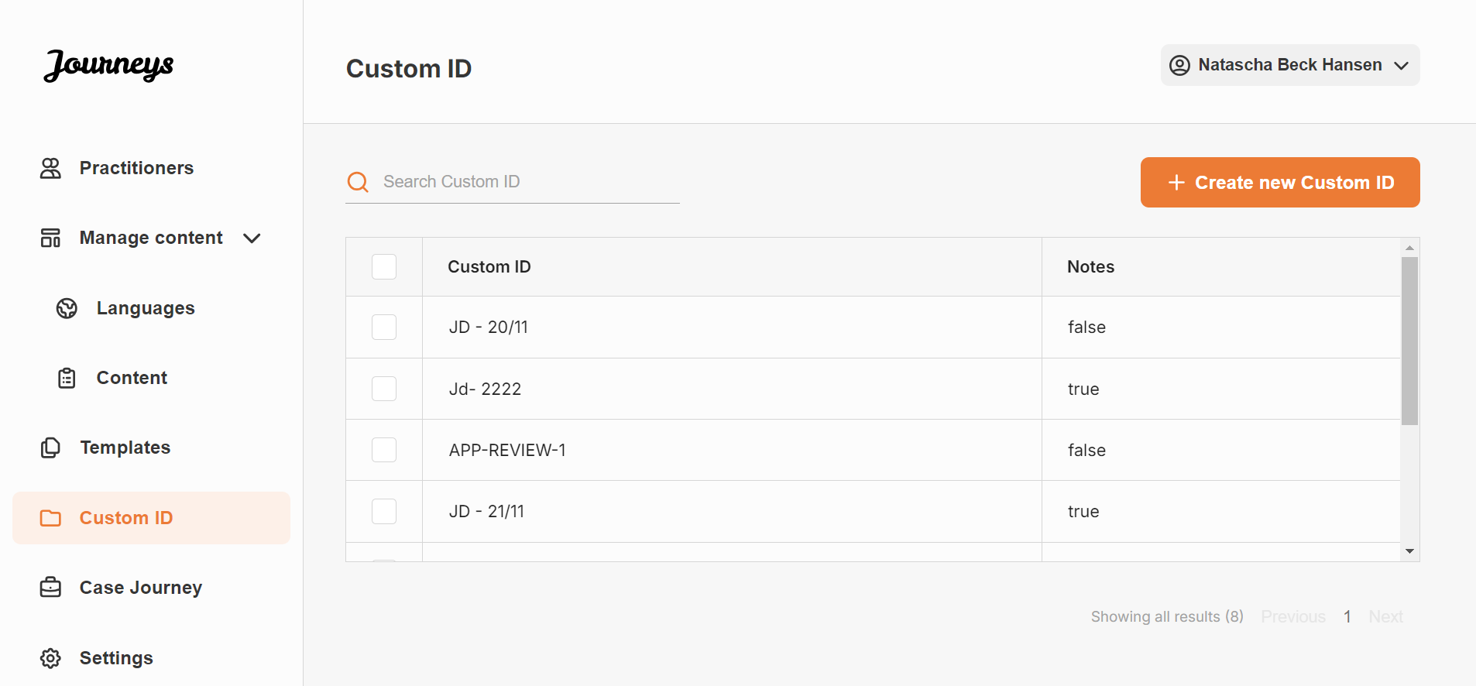
3. Come up with a distinct/identifiable but appropriate Custom ID for the child that you want to create a personalised journey for. This Custom ID will serve as a one-time passcode for the child to access their journey in the app – after the child has logged in for the first time, they will be prompted to change their access code.
4. Enable/disable notes depending on the local/national context and when you would like for the child to be able to leave private comments about the Barnahus, rooms or staff – this can be enabled/disabled at any time.
5. Share the Barnahus ID (which serves as a username) and the custom ID with the child for them to be able to access their tailored journey on the mobile app. The Barnahus ID can be found…

Creating a Custom Journey Experience
Rearrange the rooms, and tailor the language and the content you want to show, to create a custom journey for the child. The child will access their custom journey on a mobile/tablet app by entering the custom ID.
See the video tutorial here: [Insert YouTube URL]
1. Navigate to the “Custom Journey” section
2. Select “Create Custom Journey”
3. Tailor room arrangements, language preferences, and overall flow to personalize the app experience.
4. Preview the changes before finalizing the custom journey
5. Access the tailored journey on the mobile/tablet app using the customized ID

Practitioner Onboarding
The Practitioner is added to the dashboard by an Admin or the Master Admin.
As a practitioner your main role is to create custom IDs and custom journeys for children visiting your Barnahus, showing the specific rooms that they will visit and the staff they will meet during their visit. You cannot add any new content to the app, only use the already existing content that has been added by the Admins and/or the Master Admin.
To illustrate, the admin might add photos of all the people involved in your Barnahus and all the rooms. However, you as the practitioner know that on the day that a child will visit your Barnahus, they will not meet certain staff and will not visit the mental health room. In that case, you can tailor the journey to ensure that the right people and rooms are visible to them in the app, and the rest is hidden.

Accessing Your Practitioner Dashboard
1. Accept the invitation email and log in to your Practitioner dashboard.
2. Familiarise yourself with the dashboard interface and available functionalities.

Creating a Custom ID
In order to create a custom journey for a child, you must first create a unique, custom ID in the dashboard. After you’ve created the custom ID, you link the journey to this ID. The Custom ID also serves as a first-time passcode for the child to access their custom journey in the app.
See the video tutorial here: [Insert YouTube URL]
1. Navigate to the “Custom ID” section.

2. Select “Create Custom ID”
3. Come up with a distinct/identifiable but appropriate Custom ID for the child that you create the journey for. This Custom ID will serve as a one-time passcode for the child to access their journey in the app – after the child has logged in for the first time, they will be prompted to change their access code.
4. Enable/disable notes depending on the local/national context and the case (see xxx) this can be enabled/disabled at any time.
5. Share the Barnahus ID (which serves as a username) and the custom ID with the child for them to be able to access their tailored journey on the mobile app. The Barnahus ID can be found…

Creating a Custom Journey Experience
Rearrange the rooms, and tailor the language and the content you want to show, to create a custom journey for the child. The child will access their custom journey on a mobile/tablet app by entering the custom ID.
See the video tutorial here: [Insert YouTube URL]
1. Navigate to the “Case Journey” section
2. Select “Select Custom ID”
3. Tailor room arrangements, language preferences, and overall flow to personalize the app experience
4. Preview the changes before finalizing the custom journey
5. Access the tailored journey on the mobile/tablet app using the customized ID

Support and Assistance
For any issues or assistance during the onboarding process, please contact the support team at
[support email]. We are here to help you ensure a smooth and efficient setup.
Thank you for joining the Barnahus app and contributing to a better experience for Barnahus
children!
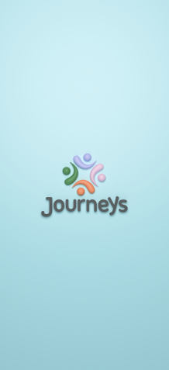

Glossary

